**Billing System And ShoppingCart**

**ACKNOWLEDGEMENT**

It’s quite difficult for an individual to make things possible without the co- operation of others. It is our privilege to than all those who have been with us from the start to end.

We wish to express our sincere gratitude to our principal Dr. ANURADHA ROY for her constant support & co-operation.

We express our sincere thanks to H.O.D of BCA Dept. Mrs.VEENA.R, & to our project guide Ms Nethravathi G.R for their constructive information and useful suggestion which helped us to complete our project successfully on time.

We wish to thanks the members of teaching & non-teaching staff of our department for their help during our project.

Lastly, We thanks our parents and friends who supported us to complete our project on time.

**Submitted By-**

Ranjith Kumar K.N

**5th SEM BCA , Seshadripuram Degree College**

**Billing System And Shopping Cart**

**DECLARATION**

I, Ranjith Kumar K.N hereby declare that the project entitled “**Organic Food And Co** ” is bona fide work carried out by us under the guidance of XYZ

This project, as presented in this report, is our original work and has not been presented for any other University award.

This project has been submitted as partial fulfilment of requirements for the **Degree of Bachelor of Computer Application of Bangalore University.**

**Submitted By-**

Ranjith Kumar K.N

**5th SEM BCA , Seshadripuram Degree College**

**Billing System And Shopping Cart**

**ABSTRACT**

The **Organic Food And Co** Project is creating for store the detail of an organic food storedocuments as Customer Details, User Details, Billing Section, Product Details also purchasedetails, and maintain the billing system of the organic food store. It is easy to use forhuman being to store and maintain an Billing System And Shopping CartDetails.

The future enhancement of this project is to develop it for the control all process of the Organic food Store, now it is to control only sales and order for food products goods. We cannot use it for sales or order of food accessories. The **Organic Food And Co** project is helping us to maintain or control all transactions of an organic food Store use by any system or Computer. The actual purpose of the project is to reduce the time to control an organic food store billing system and store records in computer.

**5th SEM BCA , Seshadripuram Degree College**

**Billing System And Shopping Cart**

**LITERATURE SURVEY**

The Indian food and grocery retail sector is in a transformation mode for various reasons like strong macro-economic fundamentals and the changing socio-economic scene. These factors are driving what were once traditional and small scale retail outlets into organized retail formats aimed at catering to the evolving tastes and needs of the discerning consumers. Economic development is frequently characterized by greater use of large, multi-line food retail outlets including supermarkets and hypermarkets (Veeck and Veeck, 2000).

Five types of analysis were found in the literature. These could be categorized as under:

1. Store Image and Satisfaction in the food and grocery retail environment

1. Nutritional consciousness due to spread of supermarkets

1. Consumer demographics and retail format choice

1. Pricing practices by modern retail

Cross shopping and retail format choice

**5th SEM BCA , Seshadripuram Degree College**

**Billing System And Shopping Cart**

**CONTENTS**

**Chapter-1 Introduction Page No.**

1.1 Objectives

1.2 Existing System

1.3 Proposed System

1.4 Brief Introduction of the project

**Chapter-2 Software Components**

2.1 Introduction to Microsoft Visual Basic 2010 Express Edition

2.2 Introduction to SQL Server 2008

**Chapter-3 Requirements and specifications**

3.1 Requirement Specification

3.1.1 Scope

3.2 Software Requirements

3.3 Hardware Requirements

**Chapter-4 System Design**

4.1 System Design

4.2 Modules of the project

4.3 Design of Data Flow Diagram

4.4 Table Design

4.4.1 User Login

4.4.2 Category Table

4.4.3 Customer Table

4.4.4 Group Table

4.4.5 Item Table

4.4.6 SaDet Table

4.4.7 SaMain Table

4.4.8 Supplier Table

4.5 Technology / Tools Selection

**Chapter-5 Testing**

5.1 TESTING

5.2 Testing is basically classified into

5.3 Testing Strategies

**Chapter-6 Screen Short**

6.1 Home Page

6.2 Customer And User Page

6.3 User Login

6.4 Main Page

6.5 Master Entries

6.6 Customer Entries

6.7 Supplier Entries

6.8 Category Entries

6.9 Group Entries

6.10 Product Entries

6.11 Import Entries

6.12 Export Billing

6.13 Stock Report

6.14 Reports Screen

6.15 Import Report

6.16 Export Report

6.17 Customer Screen

6.18 About Us Page

6.19 Products Page

6.20 Rice Page

6.21 Dals Page

6.22 Millets Page

6.23 Spices Page

6.24 Oils Page

6.25 Teas Page

6.26 Juices Page

**Chapter-7 Coding**

7.1 Start Page

7.2 Customer And User Page

7.3 User Login

7.4 Main Page

7.5 Master Entry

**Chapter-8 Conclusion**

**Chapter-9 Bibliography**

**5th SEM BCA , Seshadripuram Degree College**

**Billing System And Shopping Cart**

**INTRODUCTION**

**5th SEM BCA , Seshadripuram Degree College 1**

**Billing System And Shopping Cart**

**CHAPTER-1 INTRODUCTION**

* 1. **Objectives**

The **Organic Food And Co** project is helping us to maintain or control all transactions of an Organic food Store use by any system or Computer. The actual purpose of the project isto reduce the time to control Billing and system and store records incomputer.

**1.2 Existing System**

The existing system in an Billing And Shopping Cart Store is that when a customer enters the store he needs to go to a sales person to get the product details. In the current project the customer can make use of this application and get the product details of the desired product and add to his cart and he himself can continue for the billing section.

**1.3 Proposed System**

The future enhancement of this project is to develop it for the control all process ofthe Organic Food Product Store, now it is to control only sales and order for food goods. We cannot use it for sales or order of food products.

**1.4 Brief Introduction Of The Project**

The **Organic Food And Co** Project is creating for store the detail of an organic food storedocuments as Customer Details, Employee Details, Billing Section, Product Detailsalso purchase details, and maintain the billing system of the Organic food Store. It is easy to use for human being to store and maintain an Organic food Store Details.

**5th SEM BCA , Seshadripuram Degree College** **2**

**Billing System And Shopping Cart**

**SOFTWARE COMPONENTS**

**5th SEM BCA , Seshadripuram Degree College**  **3**

**Billing System And Shopping Cart**

**CHAPTER-2 SOFTWARE COMPONENTS**

**2.1 Introduction to Microsoft Visual Basic 2010 Express Edition**

Visual Basic 2010 Express Edition is a no-cost, streamlined, easy-to-use developmenttool for hobbyists, students, and novices. The Express Edition makes Windows programming with Visual Basic fun and easy to learn. It's also the perfect way for experienced Visual Basicdevelopers to try out new features.

Features:

• Easily design great-looking and easy-to-use applications using an intuitive, drag-and-drop interface designer.

• Built-in support for Windows XP,7,8,10 Themes lets you easily create applications with aWindows XP,7,8,10. look and feel.

• Over 30 new controls simplify development.

• In-place menu editor enables quic and easy creation of main menus and right-clickcontext menus.

• My namespace provides intuitive access to common functions working with files,accessing the registry, and utilizing applications settings and resources.

• Code colorization,syntax checking,and IntelliSense provide an intuitive development experience.

• AutoCorrect can suggest and apply fixes for more than 230 common programmingerrors.

• Don't write that code yourself! Visual Basic Express can write it for you with ove400 built-in IntelliSense code snippets that provide templates for common codingtasks.

• Drag and drop data from your database onto your Windows application to easilycreate fully-functional data-driven applications.

• Create data-enabled applications using SQL Server 2008 Express.

• Visually design queries and databases using the built-in database design tools.

**5th SEM BCA , Seshadripuram Degree College 4**

**Billing System And Shopping Cart**

**2.2 Introduction to SQL Server 2008**

Microsoft SQL Server 2008 Express Edition (SQL Server Express) is a powerful andreliable data management product that delivers rich features, data protection, andperformance for embeded application clients, light Web applications, and local data storeDesigned for easy deployment and rapid prototyping, SQL Server Express is available at nocost, and you are free to redistribute it with applications. SQL Server Express is designed tintegrate seamlessly with your other server infrastructure investments.

Supported Operating System

• Windows 2000 Service Pack 4, Windows Server 2003 Service Pack 1, Windows XPService Pack 2 ,Windows 7 Service Pack 3, Windows 10 Service Pack 1

• Computer with Intel or compatible Pentium III 600 MHz or faster processor (1 GHzor faster is recommended)

• Minimum of 192 MB of RAM (512 MB or more is recommended)

• 525 MB of available hard disk space.

**5th SEM BCA , Seshadripuram Degree College 5**

**Billing System And Shopping Cart**

**REQUIREMENTS AND SPECIFICATIONS**

**5th SEM BCA , Seshadripuram Degree College 6**

**Billing System And Shopping Cart**

**CHAPTER-3 REQIREMENTS AND SPECIFICATIONS**

About the Specifications for the better performance of the project

**3.1 Requirement Specification**

The Software requirement specification provides a complete description of all“**Organic Food And Co**” the function and specification of the “**Organic Food And Co**”.

The expected audience of this document is to provide the Customer to check and compare the products and provide the complete billing section.

**3.1.1 Scope**

The “**Organic Food And Co** ” Application is designed for the customer to select anitem from the database and add it to the cart and continue for the billing section.

This application allows the admin Registration and save the details into the database. The Database will be held in an SQL database on the Server.

**3.2 Software Requirements**

Front End Tool : Microsoft Visual Basic 2010 Express Edition (VB.Net)

Programmer Tool : Microsoft Visual Basic 2010 Express Edition (VB.Net)

Back End Tool : Microsoft SQL Server 2008.

Operating System : Windows 10

**3.3 Hardware Requirements**

Processor : Intel(r) Celeron(r).

RAM : 2 GB

Hard Disk : 500 GB

Monitor : 1024*765 pixel colour monitor

**5th SEM BCA , Seshadripuram Degree College 7**

**Billing System And Shopping Cart**

**SYSTEM DESIGN**

**5th SEM BCA , Seshadripuram Degree College 8**

**Billing System And Shopping Cart**

**CHAPTER-4 SYSTEM DESIGN**

A Blue Print for the development and analysis of the “**Organic Food And Co**”.

**4.1 System Design**

System design provides the understandings and procedural details necessary for implementing the system recommended in the system study. Emphasis is on translating the performancerequirements into design specifications. The design phase is a transition from a useroriented document (System proposal) to a document oriented to the programmers ordatabase personnel.

System design goes through two phases of development:

• Logical Design

• Physical Design

A data flow diagram shows the logical flow of the system. For a system it describes the input(source), output (destination), database (data stores) and procedures (data flows) all in aformat that meet’s the user’s requirement. When analysis prepares the logical design, theyspecify the user needs at the level of detail that virtually determines the information flow intil an out of the system and the required data resources. The logical design also specifies inputforms and screen layouts.

The activities following logical design are the procedure followed in the physical design e.g.,producing programs, software, file and a working system. Design specifications instruct theuser about what system should do.

**Five Objectives of design input focus on:**

• Controlling the amount of input required.

• Avoid delay.

• Avoiding errors in data.

• Avoiding extra Steps.

• Keeping the process simple.

**5th SEM BCA , Seshadripuram Degree College 9**

**Billing System And Shopping Cart**

**4.2 Modules of the Project**

“**Billing System And Shopping Cart** ” has in all 2 modules and shall be implemented in phases.The number of phases and the modules will be implemented as follows.

• User Module: Allows the Administrator to access the Application without any limitations.

• Customer Module: Allows the customers to have a look over the application,browse over thevarious categories of products. Buy the products from the application.

**4.3 Data Flow Diagram**

**5th SEM BCA , Seshadripuram Degree College 10**

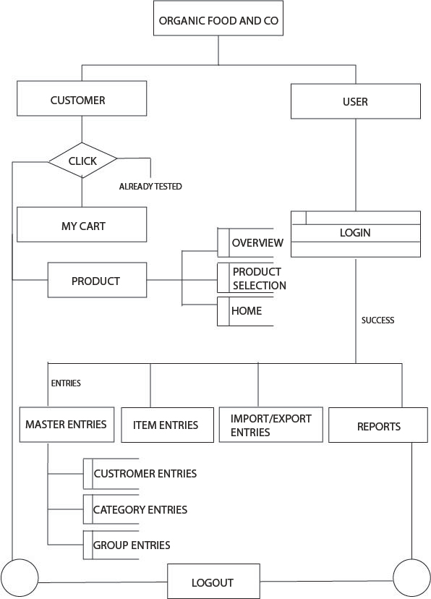

**11**

**Billing System And Shopping Cart**

**TESTING**

**5th SEM BCA , Seshadripuram Degree College 12**

**Billing System And Shopping Cart**

**CHAPTER-5 TESTING**

**5.1 TESTING**

The development of software systems involves a series of production activities whereopportunities for injections of human fallibilities are enormous. Errors may begin to occur atvery inception of the process where the objectives, may be erroneously or imperfectly specified, as well as in later design and development stages. Because of human perform and communicate in perfection, software development is accompanied by qualityassurance activity.Software testing is a critical element of software quality assurance and represents the Ultimate review of specification, design and coding. In general, testing starts with test plan.The test plan identifies all testing related activities that need to be performed along with thescheduled and guidelines for testing. The plan also specifies the levels of testing that need tobe done, by identifying the different testing units. Based on the plan, the testing commences.For each unit specified in the plan, first the test cases and reports are produced. Testingpresents an Interesting anomaly for a software engineer.

**5.2 Testing is basically classified into**

• Blac Box Testing

• White Box Testing

**Black Box Testing**

Blac box testing focuses in the functional requirements of the software. It enablessoftware engineer to derive sets of inputs conditions that will fully exercise all functionalrequirements for a program.

**Black Box testing attempts to find errors in the following categories:**

• Incorrect or missing function

• Interface errors

• Errors in data structures or external database access

• Performance errors

• Initialisation and termination error

• Errors in data structures or external database access

• Performance errors

**5th SEM BCA , Seshadripuram Degree College 13**

**Billing System And Shopping Cart**

• Initialisation and termination error

• Errors in data structures or external database access

• Performance errors

• Initialisation and termination error

Generally Black Box testing is applied for high level testing such as system testing,acceptance testing.

**White Box Testing**

White box testing, sometimes called glass box testing is a test case design methodwhich uses the control structure of the procedural design to derive test cases.

**White Box Testing is applied to:**

• Exercise all logical decision on their true and false sides

• Exercise all loops at their boundaries and within their operational bounds

• Exercise internal data structures to assure their validity.

**5.3 Testing Strategies**

• Unit Testing

• Integration Testing

• Acceptance Testing

**Unit Testing:**

Unit testing focuses on the verification effort on the smallest unit of software desig module. Using the detailed design description as a guide, important control parts are tested touncover errors within the boundary of the modules. The relative complexity of tests and theerrors detected as a result is limited by constraint scope established for unit testing. The unitest is always white box oriented, and the step can be conducted in parallel for multiple modules.

**5th SEM BCA , Seshadripuram Degree College 14**

**Billing System And Shopping Cart**

**Integrated Testing:**

With unit testing the modules may function properly, but at time they may haveinadvertent, adverse affect on another; sub function, when combined, may not produce thedesired major function; Individually acceptable impression may be magnified to unacceptablelevel; global data structures may present problems.Integration testing is symmetric technique for constructing the program structurewhile at the same time conducting tests to uncover errorsassociated with interfacing. Theobjective is to take unit tested modules and builds program structure that has been dictatedby the design.

**Acceptance Testing:**

System under consideration is tested for acceptance by constantly keeping in touchwith the prospective system. Series of acceptance test are conducted to enable the user tovalidate all requirements. Acceptance testing involves planning and execution of

• Functional Test

• Performance Test

• Stress Test

Functional test is the exercising of the code with nominal input values for which the expectedvalues for which the expected values for which the expected values are known.Performance test determines the amount of execution time spent in various parts of the unit,program throughput and response time. This test is productive at the subsystem and system level.

Stress test is designed to intentionally break the unit and the strength and the limitation of theprogram are examined.

**5th SEM BCA , Seshadripuram Degree College 15**

**Billing System And Shopping Cart**

**SCREEN SHORTS**

**5th SEM BCA , Seshadripuram Degree College 16**

**Billing System And Shopping Cart**

**CHAPTER-6 I/O Screens**

**6.1 Start Screen:**

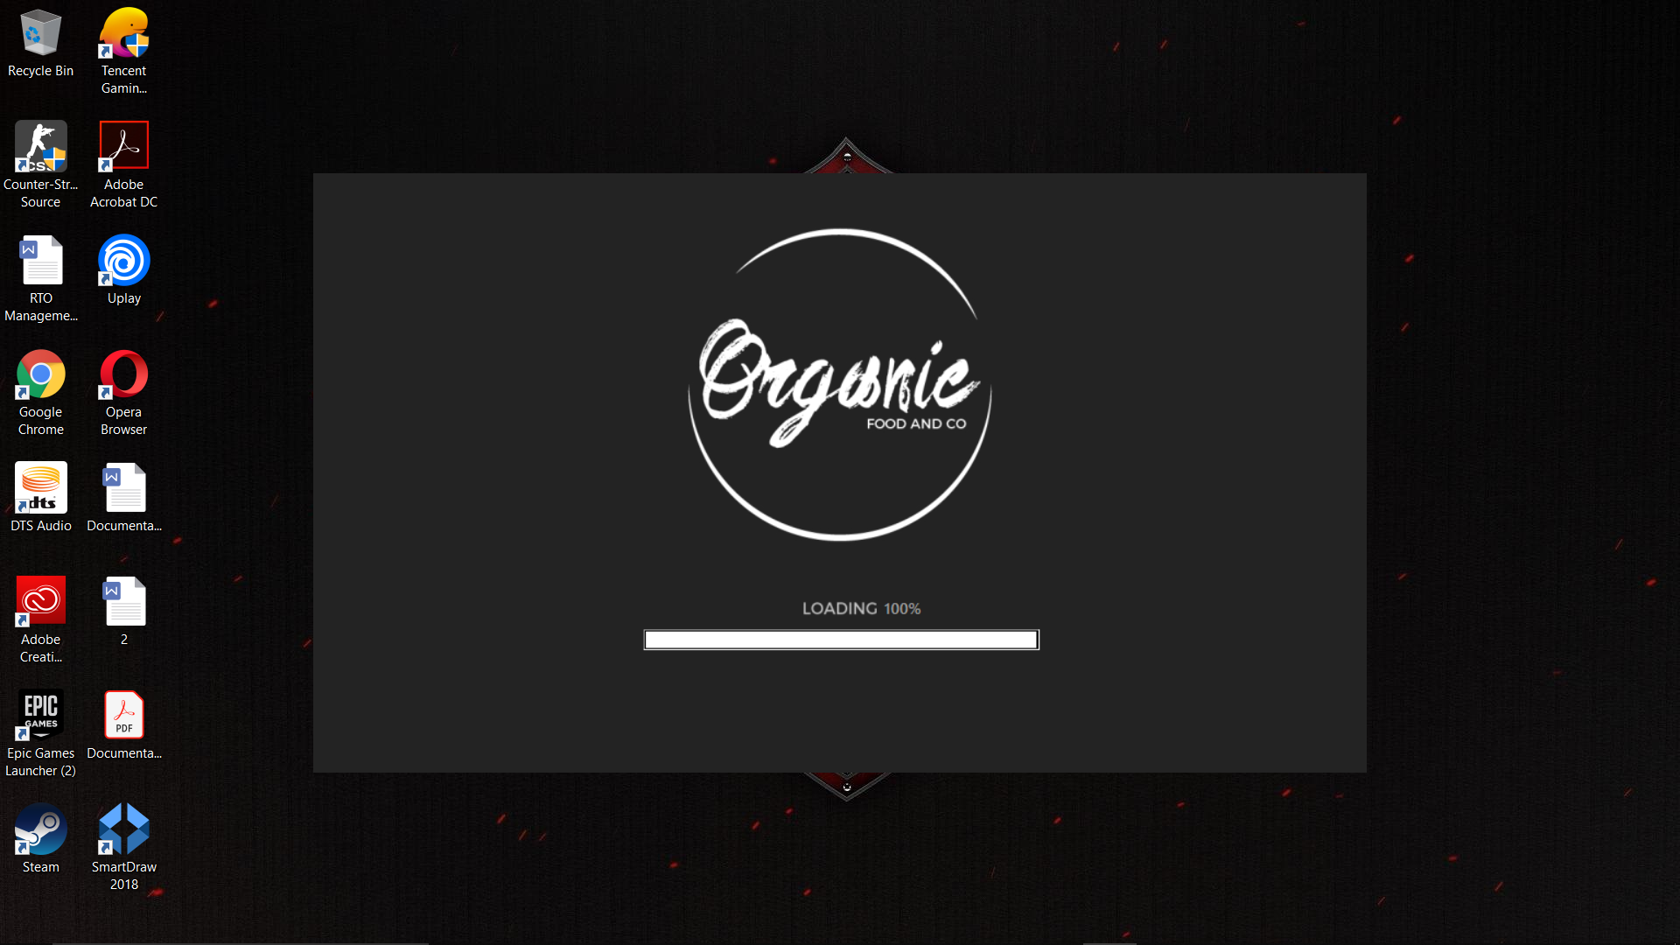

**6.2 Customer And User Page:** 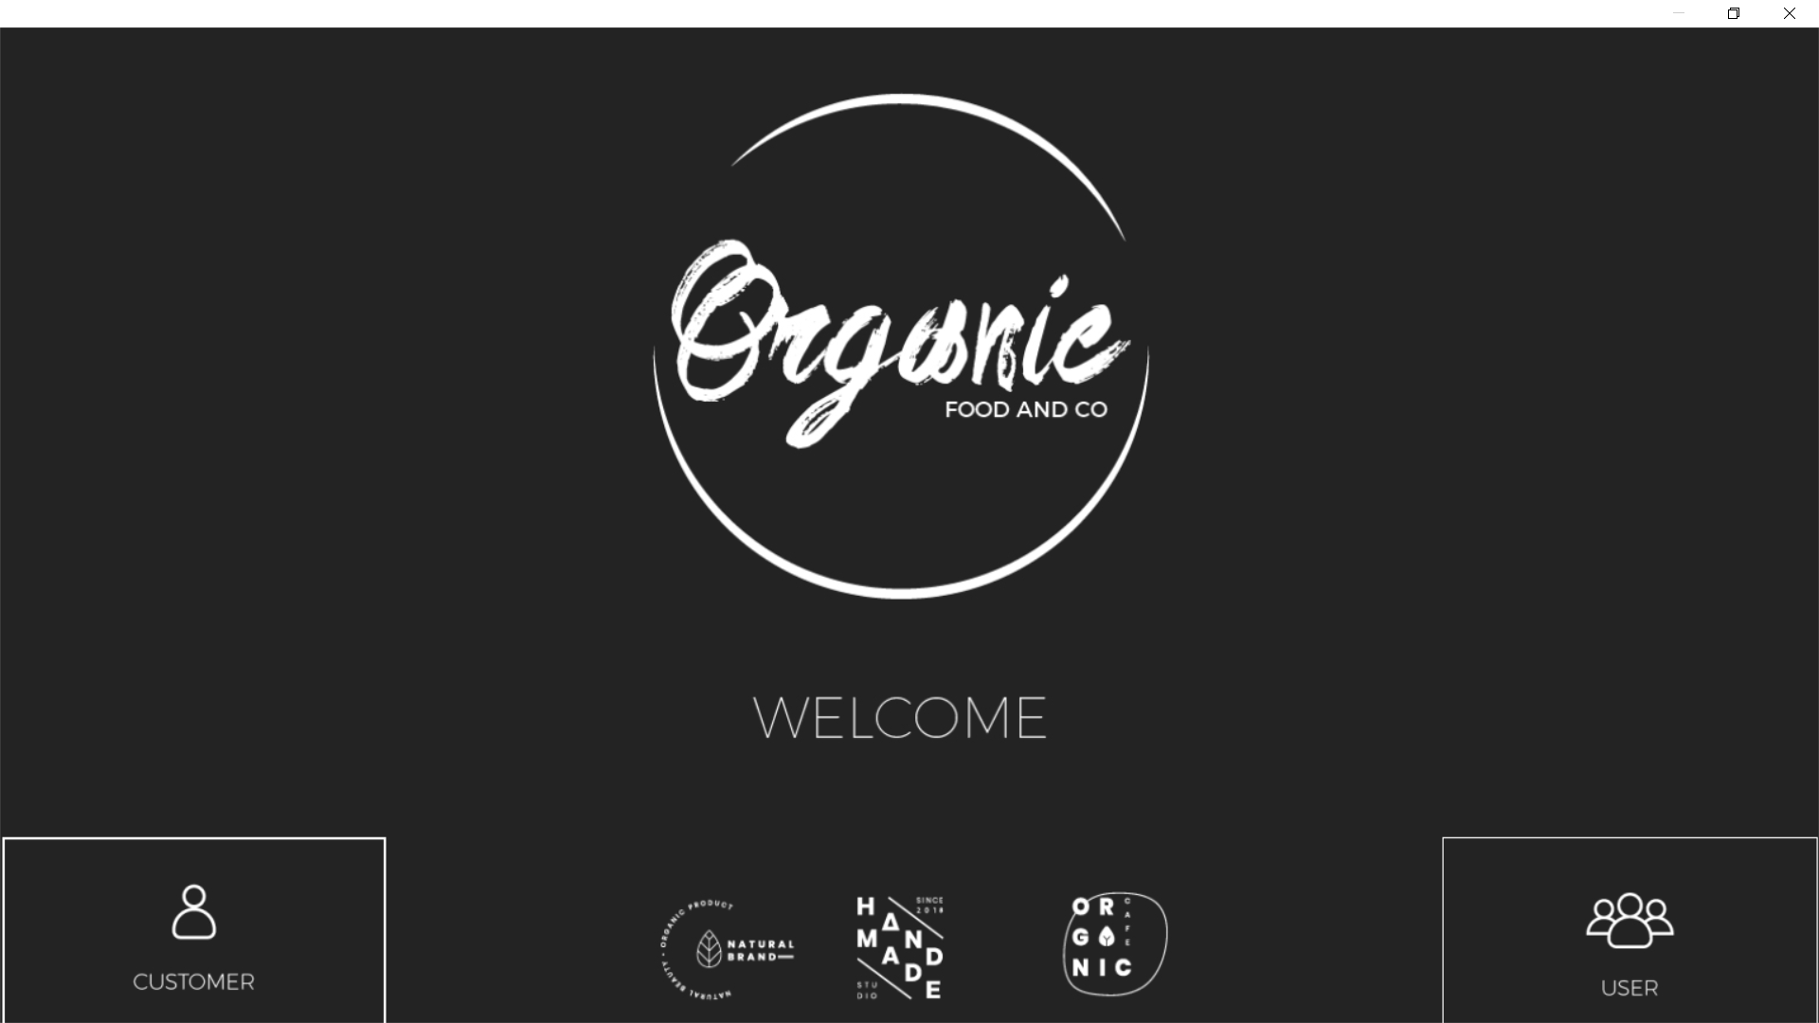

**5th SEM BCA , Seshadripuram Degree College 17**

**Billing System And Shopping Cart**

**6.3 UserLogin Page:**

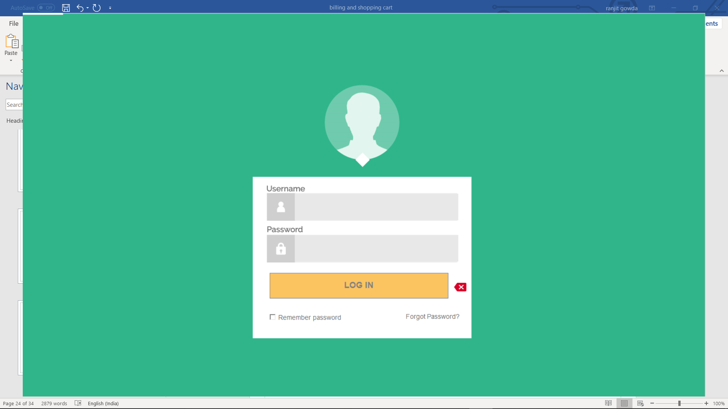

**DataBase:**

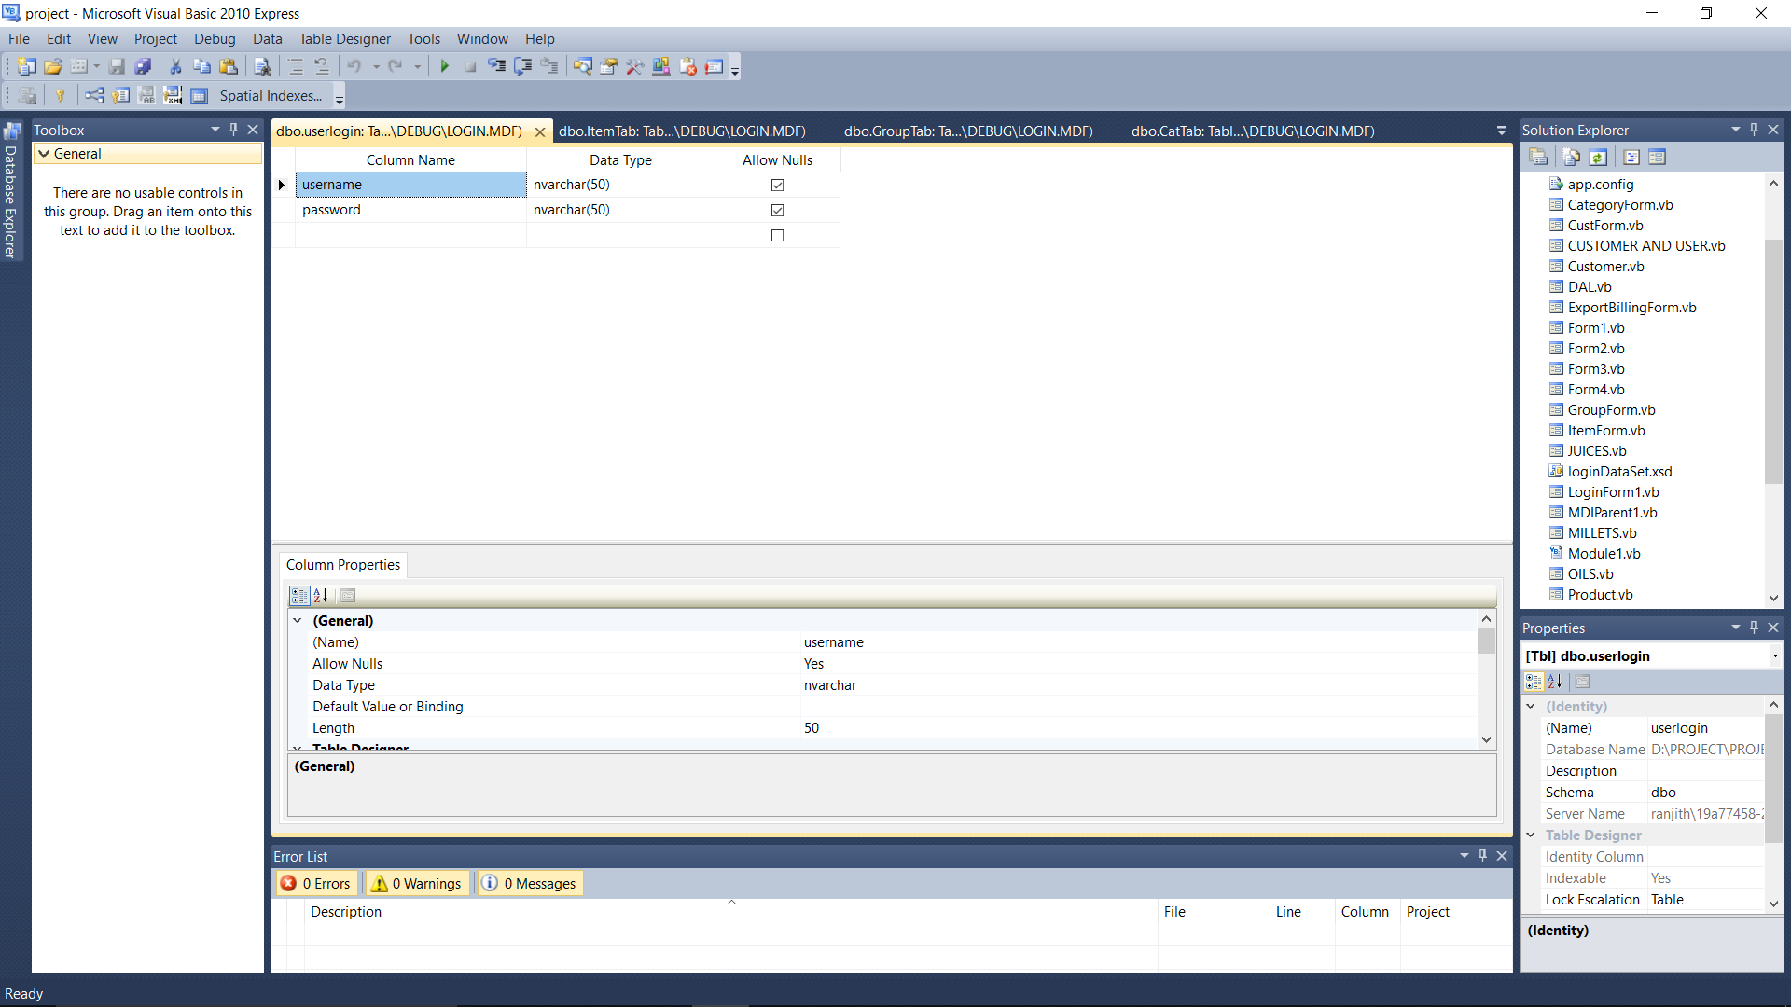

**5th SEM BCA , Seshadripuram Degree College 18**

**Billing System And Shopping Cart**

**6.4 Main Page:**

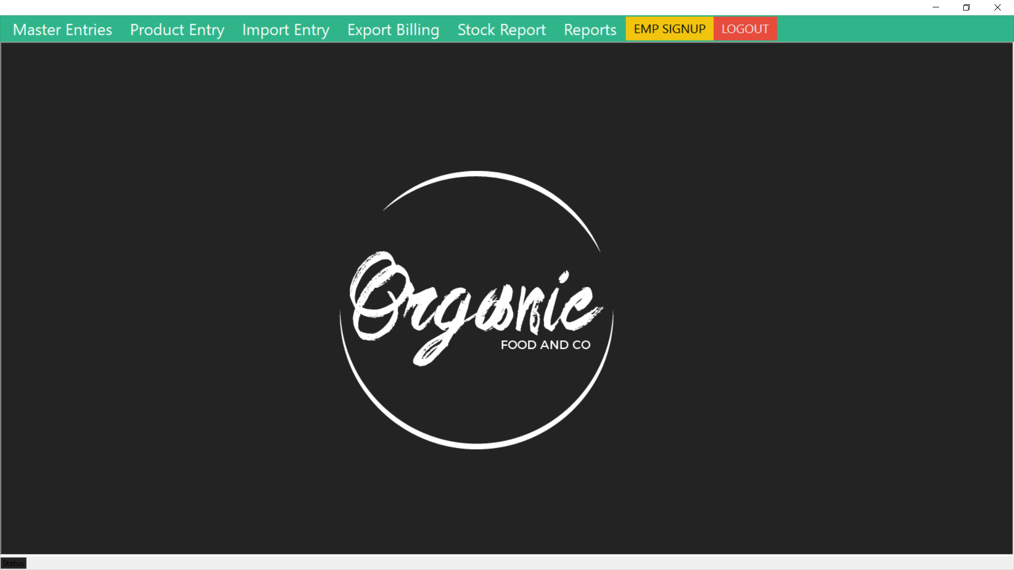

**6.5Master Entries:** 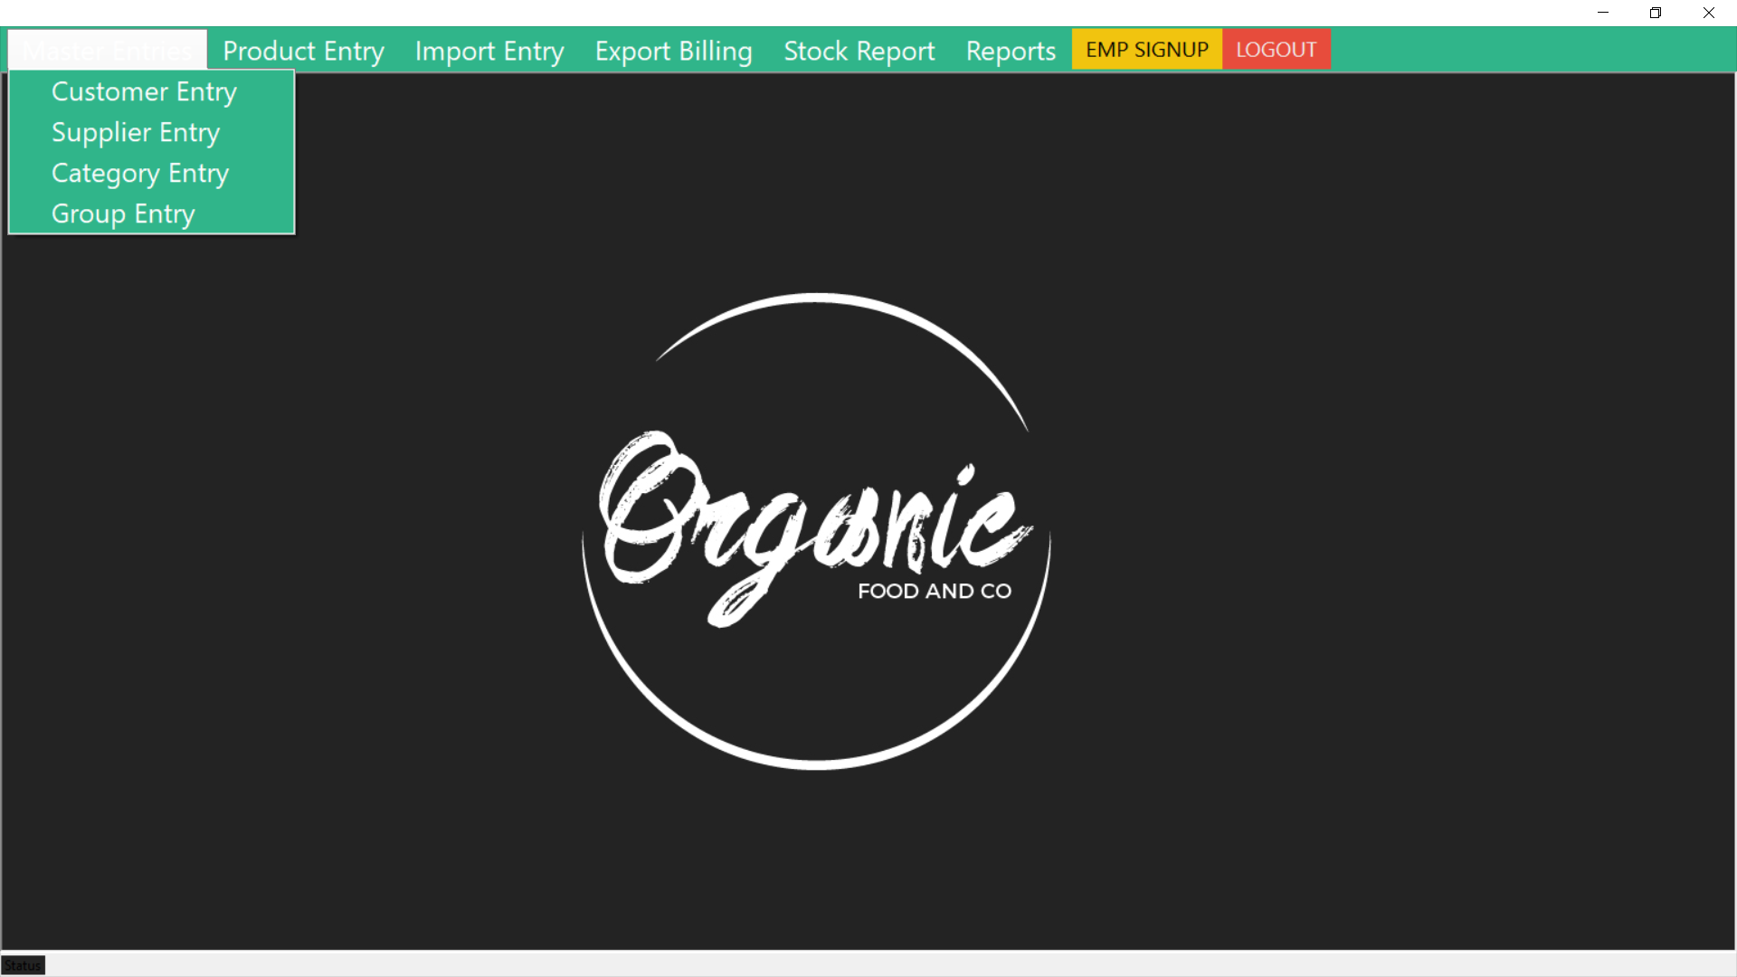

**5th SEM BCA , Seshadripuram Degree College 19**

**Billing System And Shopping Cart**

**6.6 Customer Entries:**

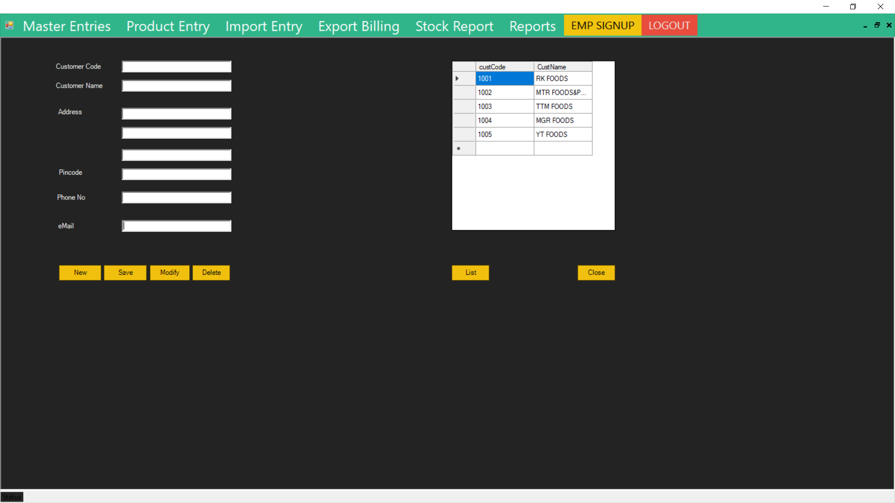

**DataBase:**

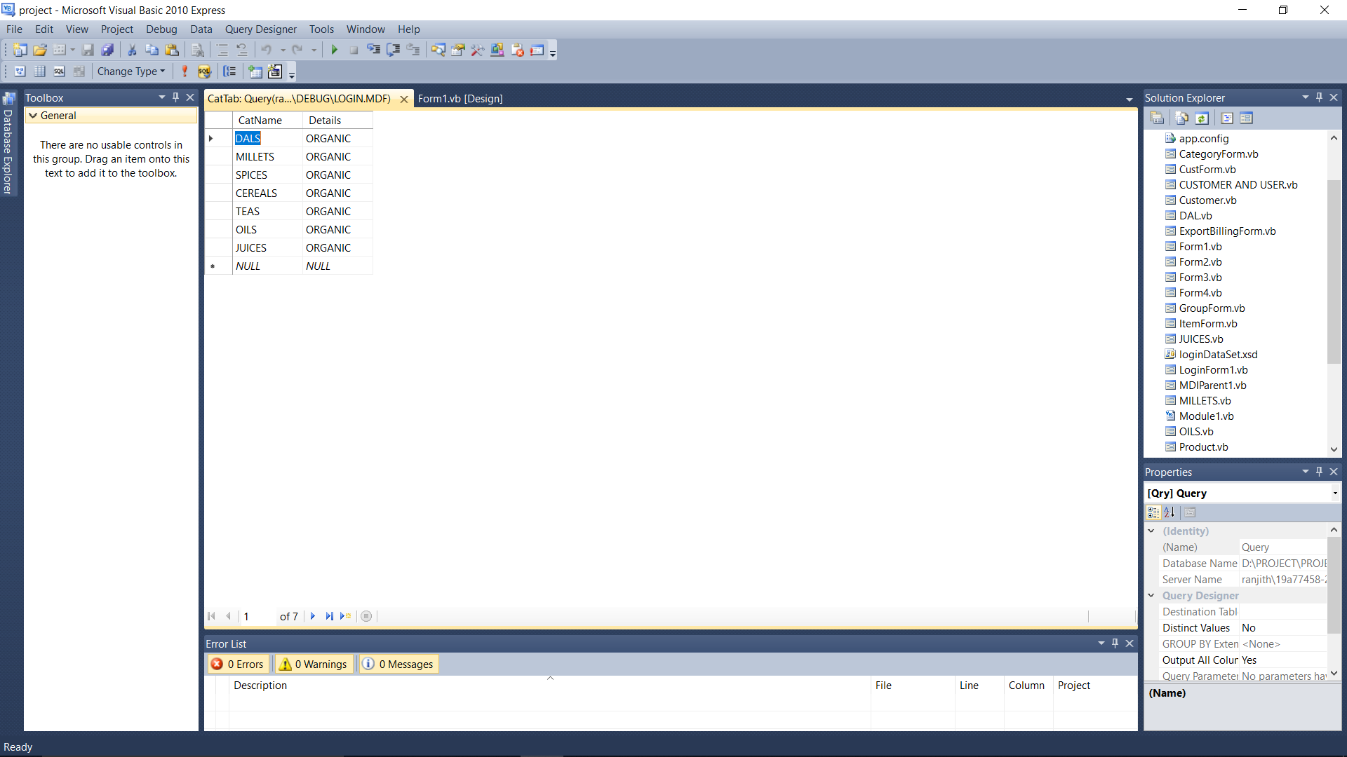

**5th SEM BCA , Seshadripuram Degree College 20**

**Billing System And Shopping Cart**

**6.7 Supplier Entries:**

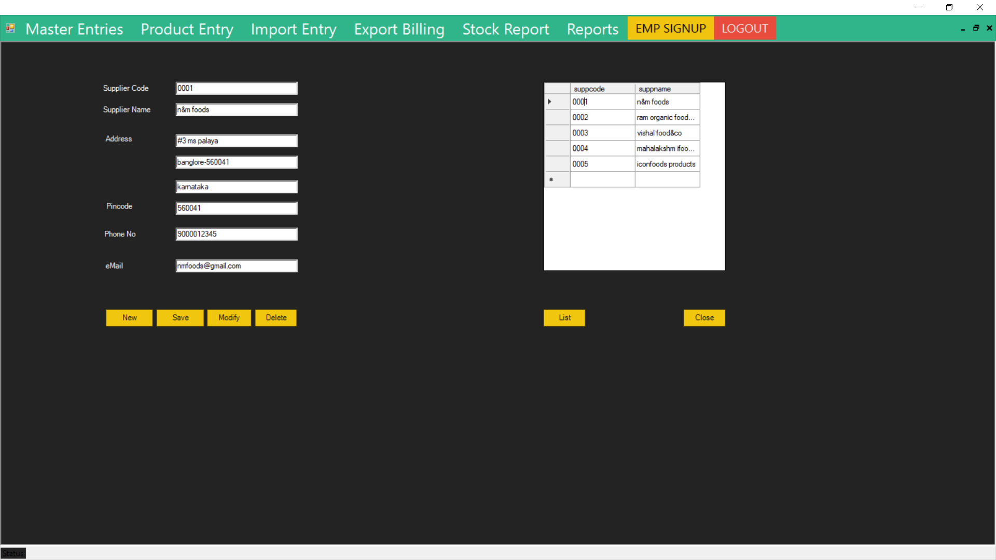

**DataBase:**

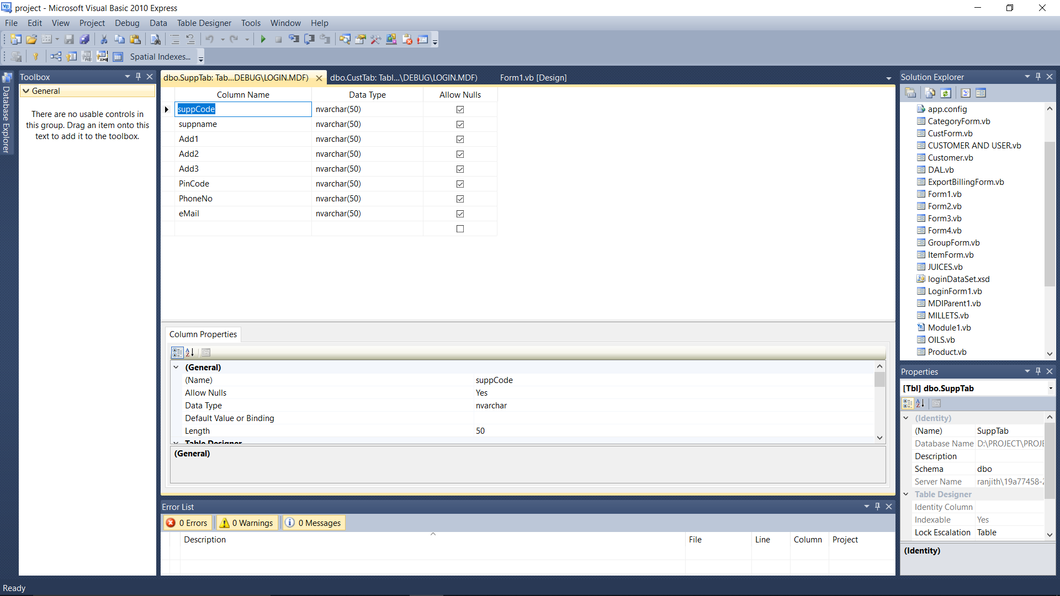

**5th SEM BCA , Seshadripuram Degree College 21**

**Billing System And Shopping Cart**

**6.8 Category Entries:**

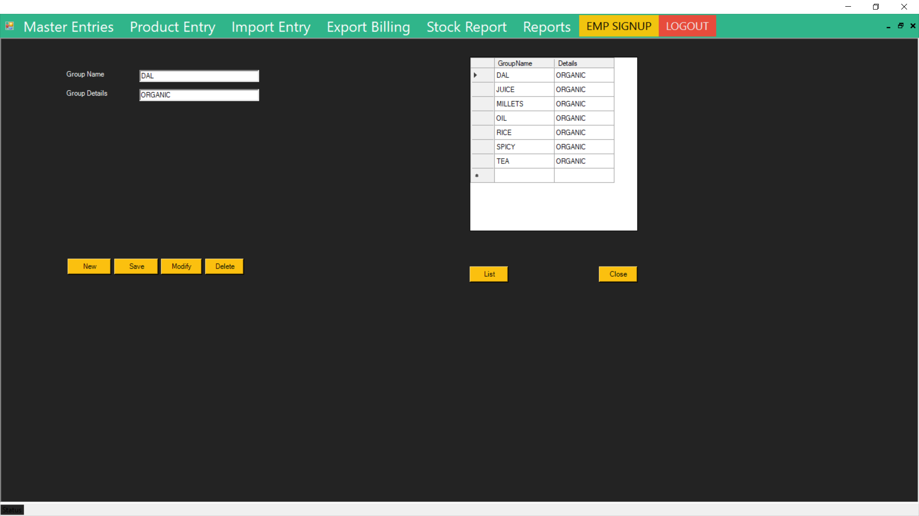

**DataBase:** 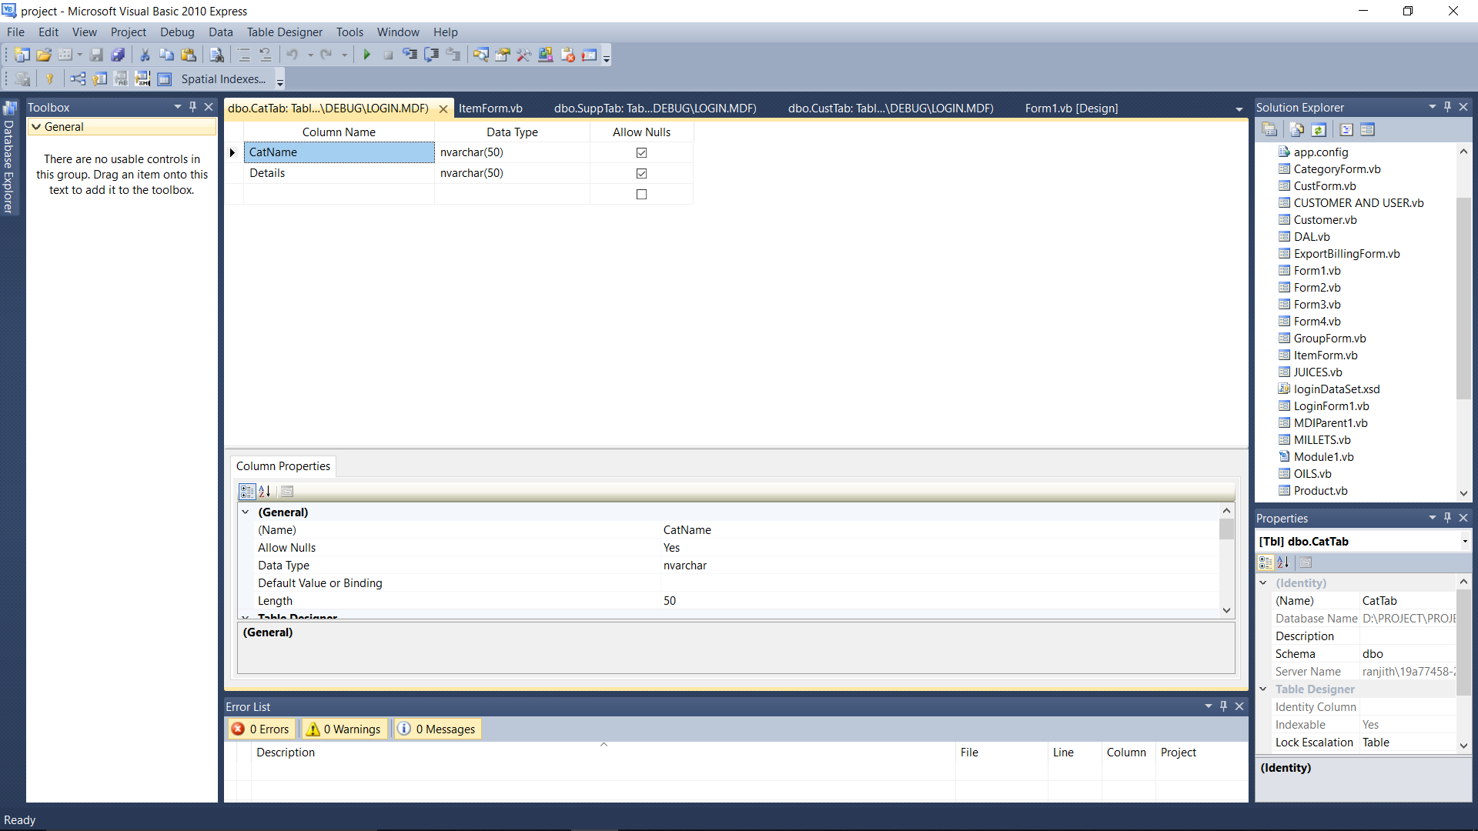

**5th SEM BCA , Seshadripuram Degree College 22**

**Billing System And Shopping Cart**

**6.9 Group Entries:**

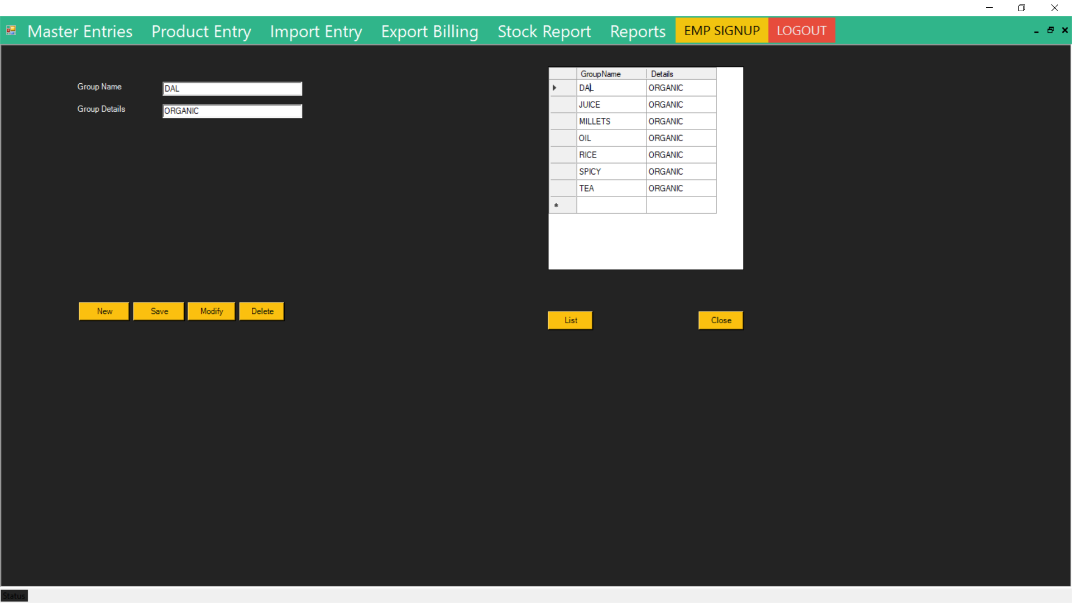

**DataBase:** 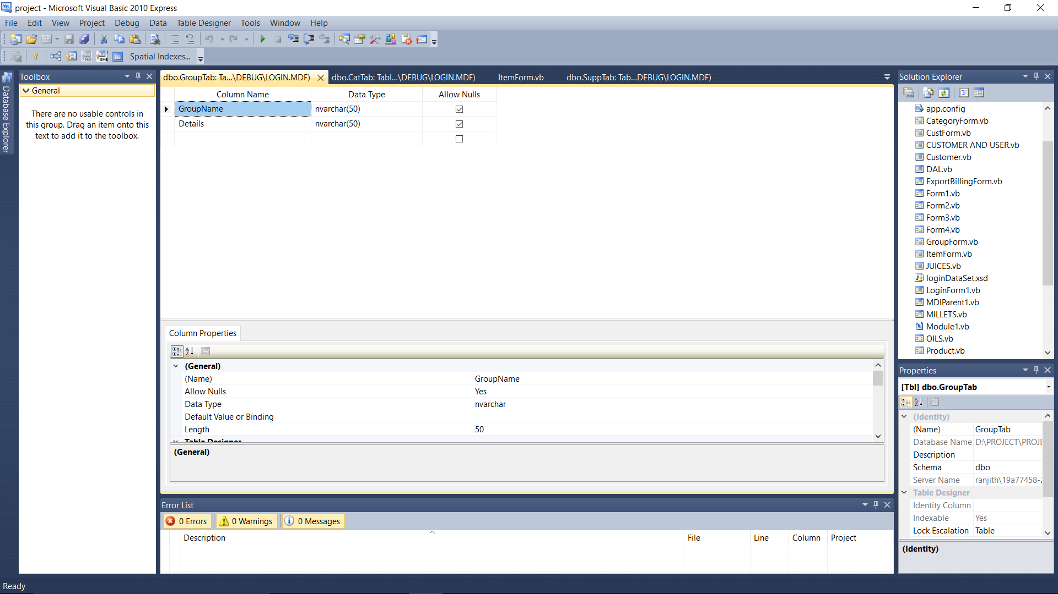

**5th SEM BCA , Seshadripuram Degree College 23**

**Billing System And Shopping Cart**

**6.10 Product Entries:**

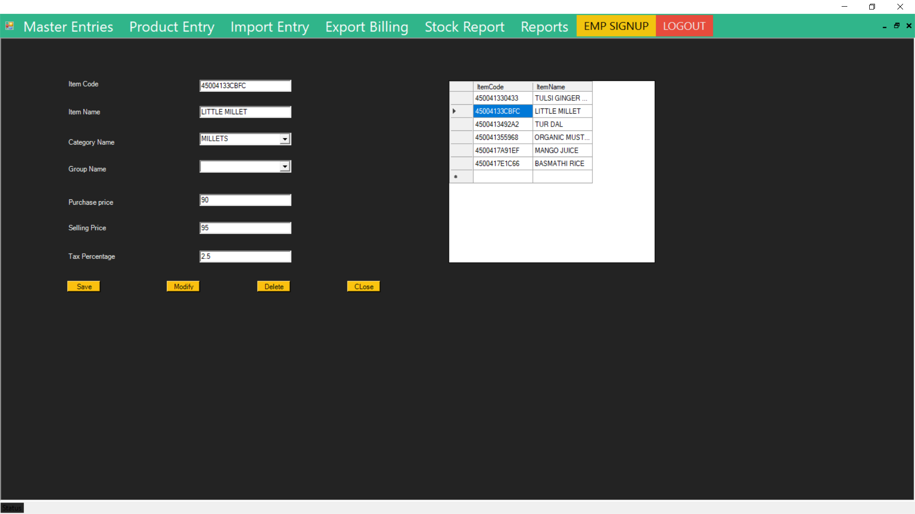

**DataBase:** 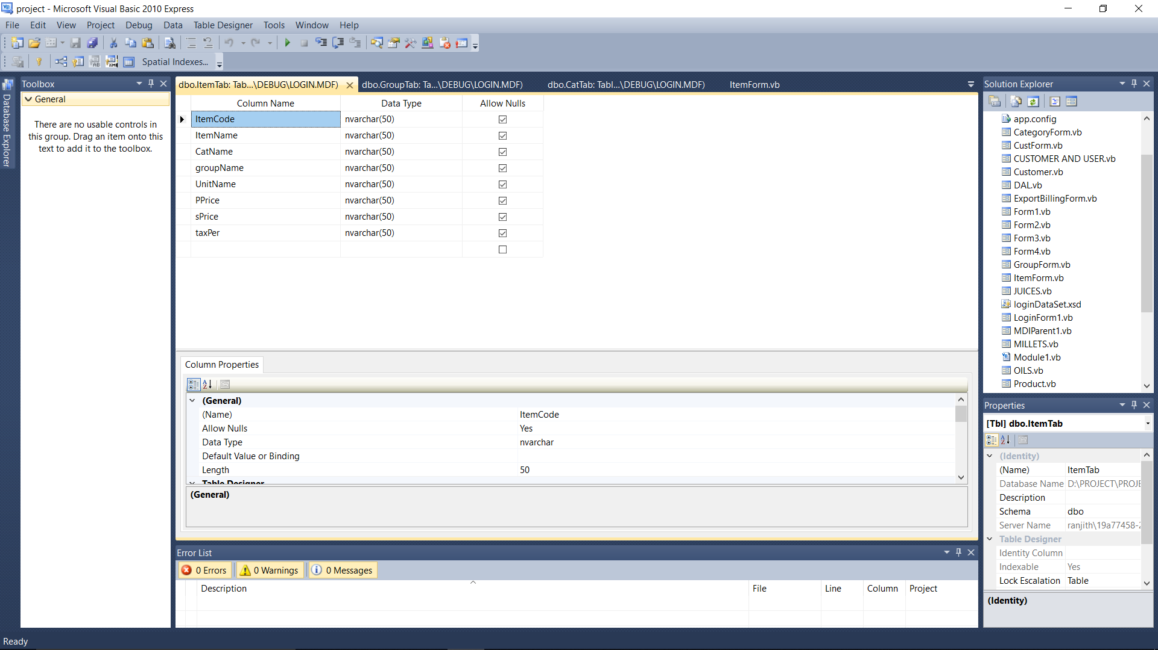

**5th SEM BCA , Seshadripuram Degree College 24**

**Billing System And Shopping Cart**

**6.11 Import Entries:**

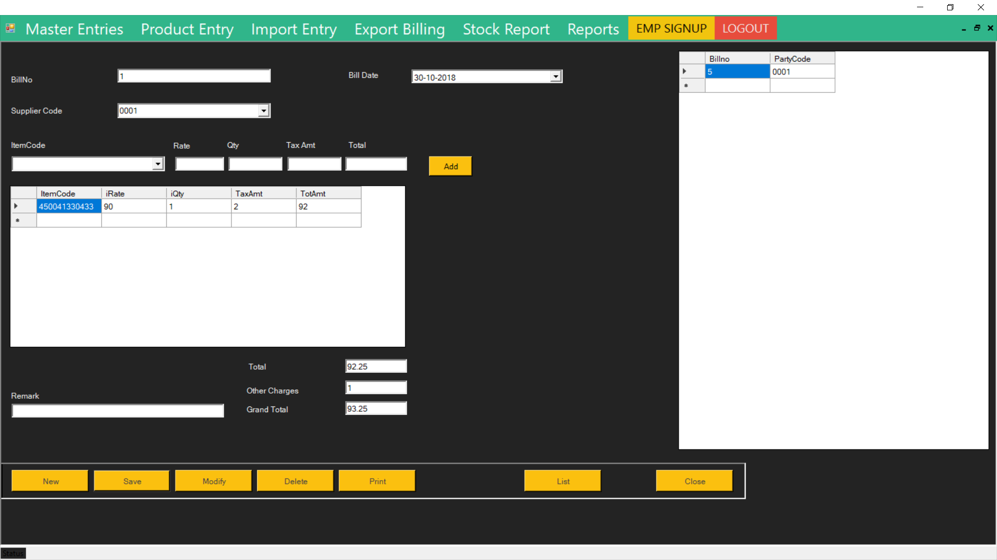

**DataBase:** 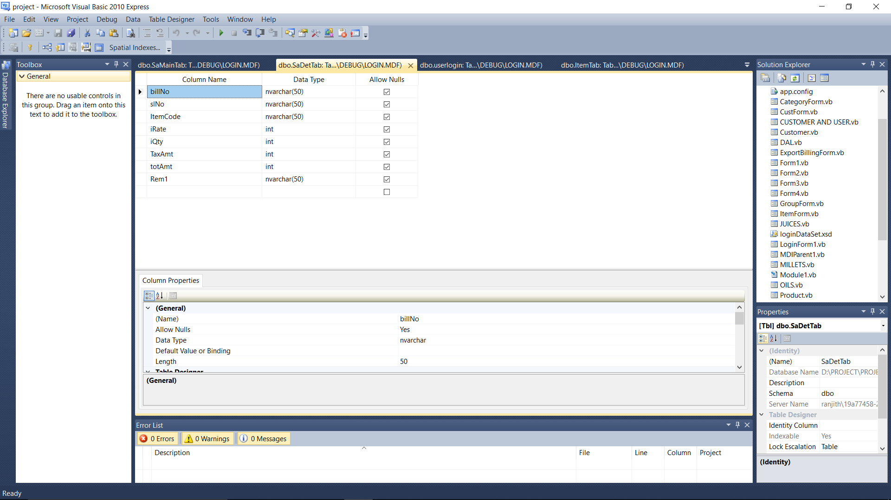

**5th SEM BCA , Seshadripuram Degree College 25**

**Billing System And Shopping Cart**

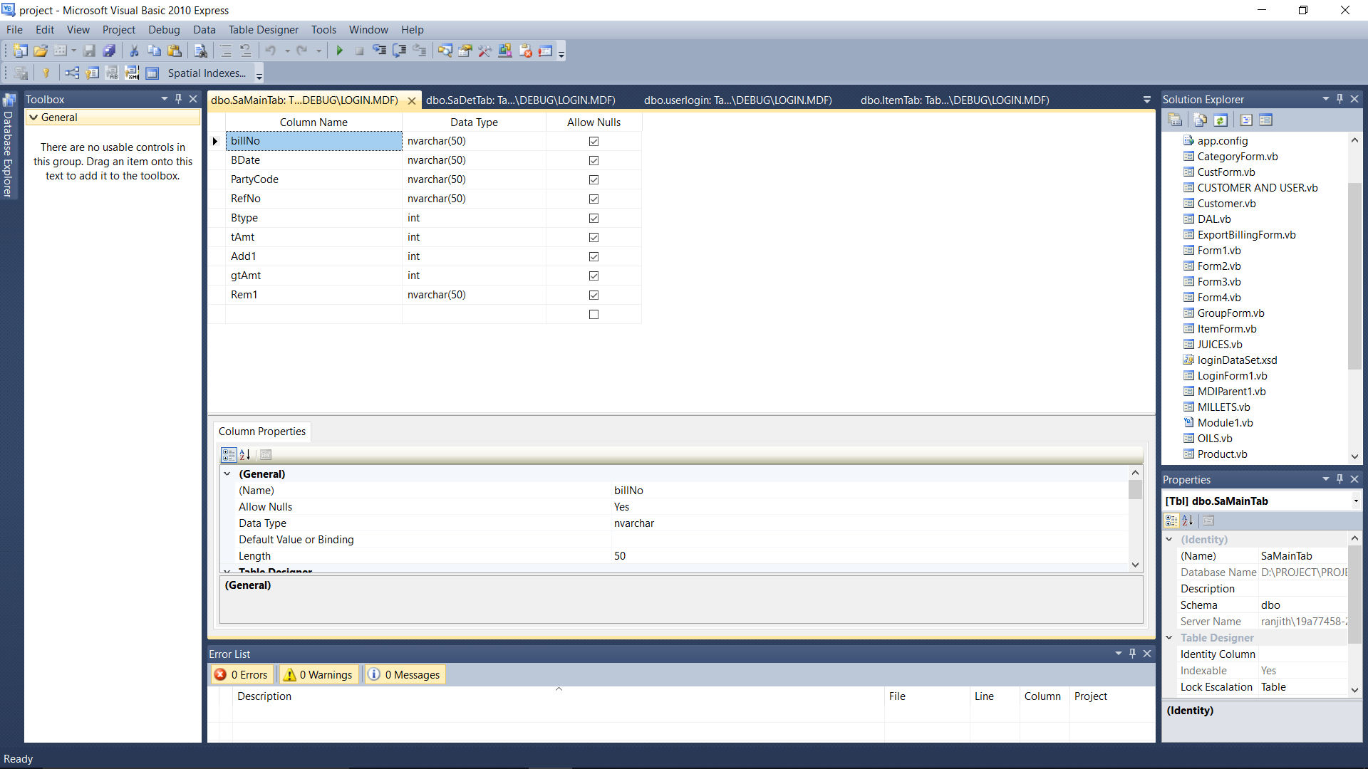

**6.12 Export Entries:** 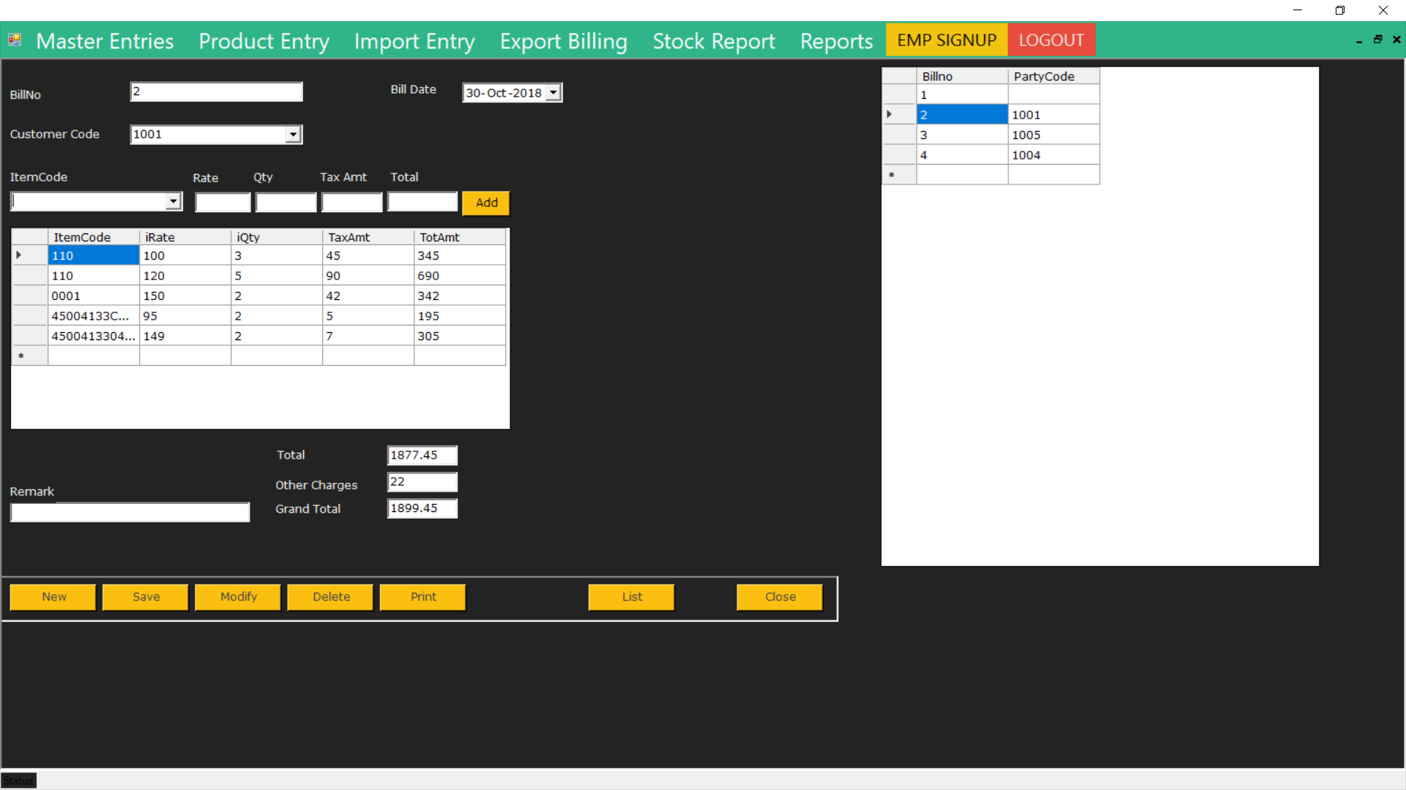

**5th SEM BCA , Seshadripuram Degree College 26**

**Billing System And Shopping Cart**

**DataBase:** 



**5th SEM BCA , Seshadripuram Degree College 27**

**Billing System And Shopping Cart**

**6.13 Stock Report:**

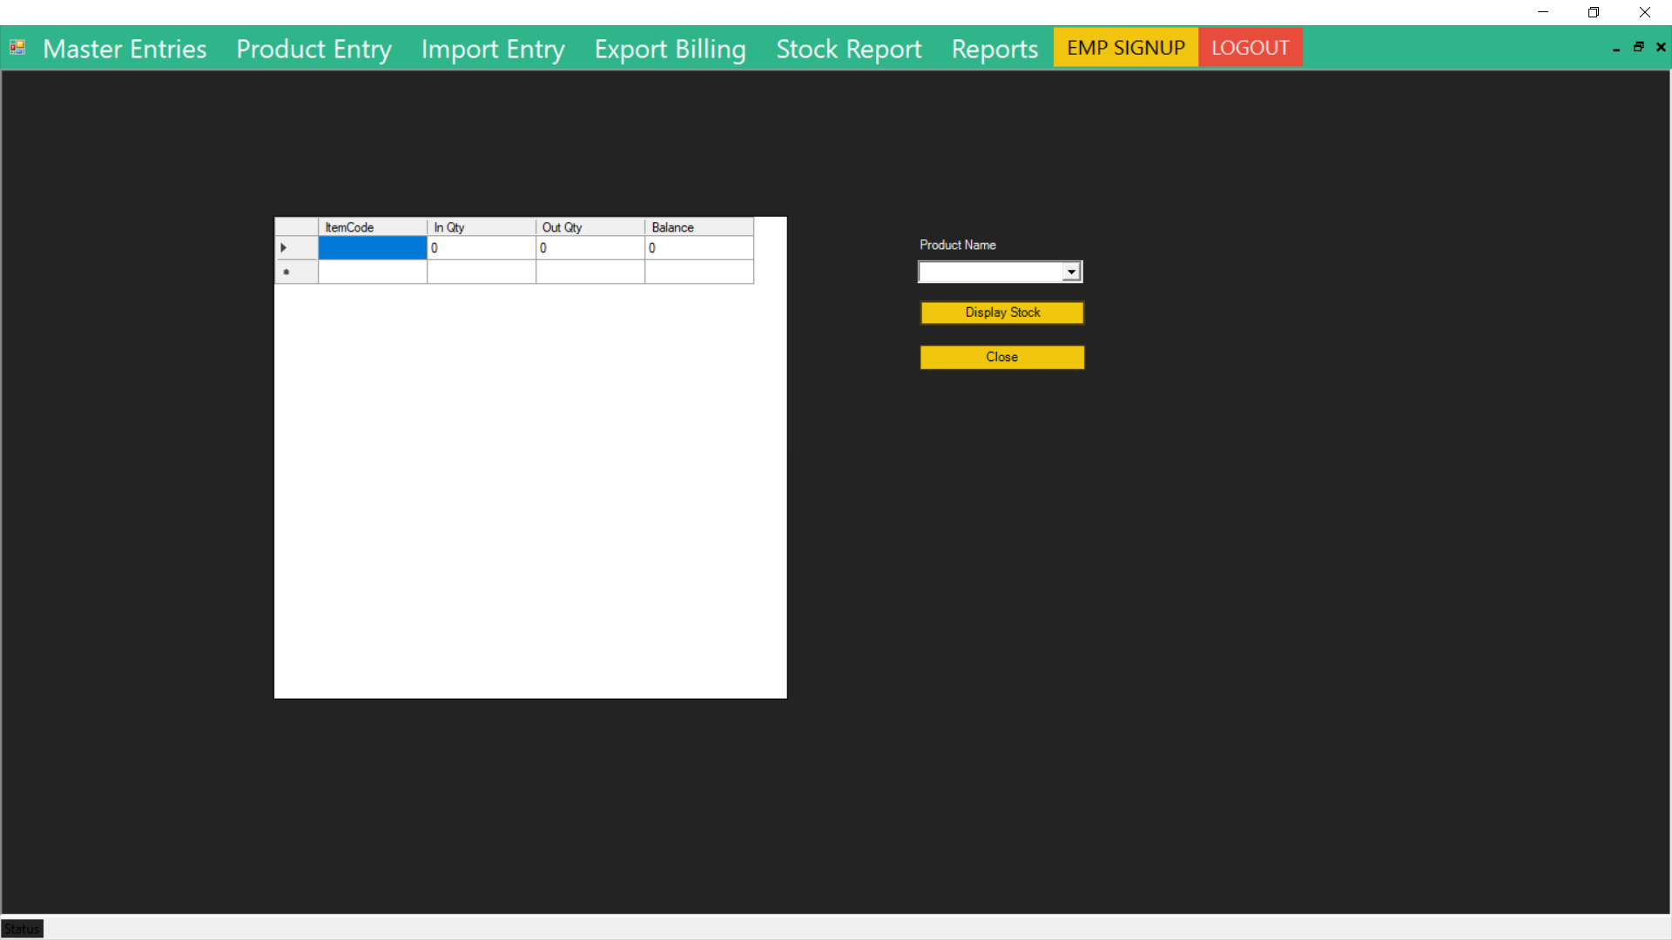

**6.14 Report Screen:**

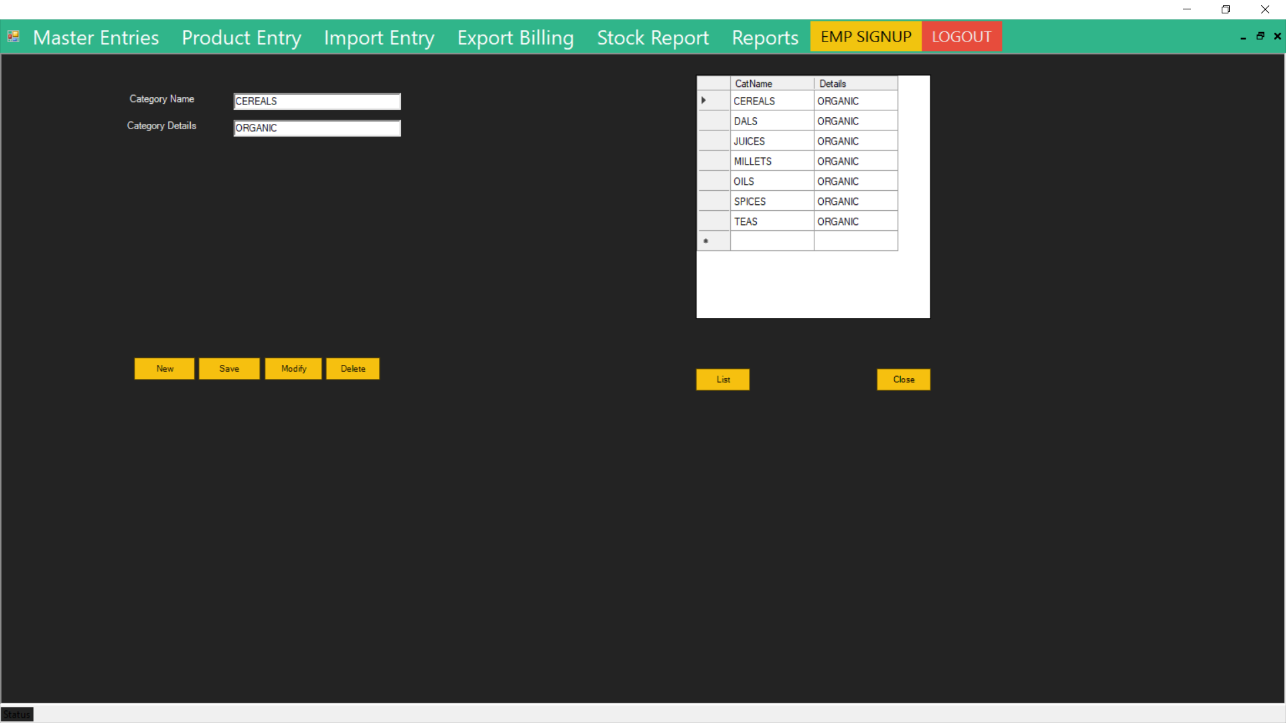

**5th SEM BCA , Seshadripuram Degree College 28**

**Billing System And Shopping Cart**

**6.15 Import Screen:**

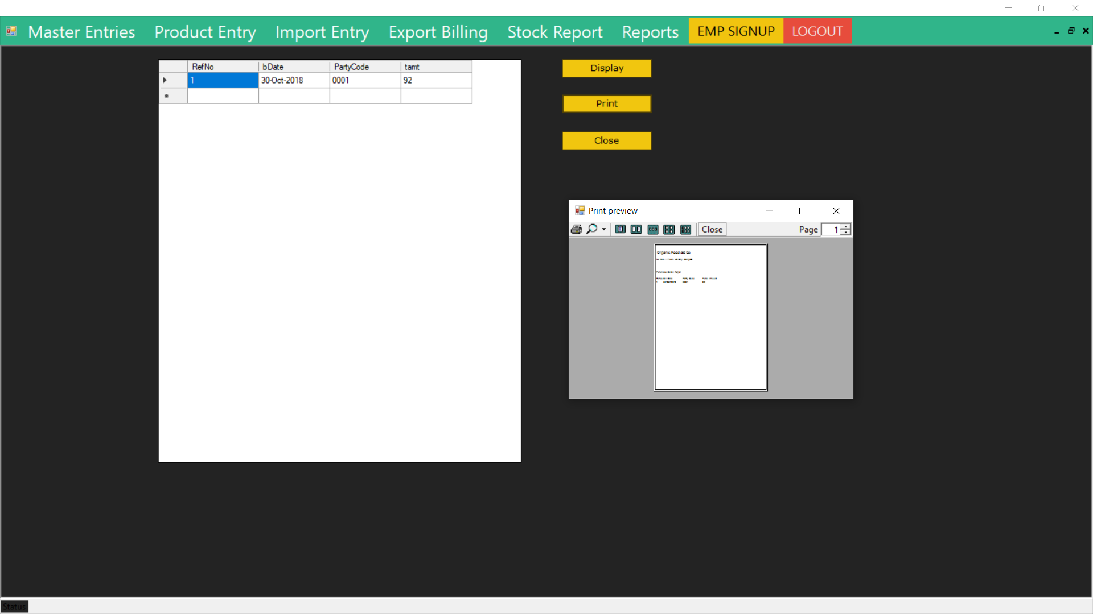

**6.16 Export Screen:**

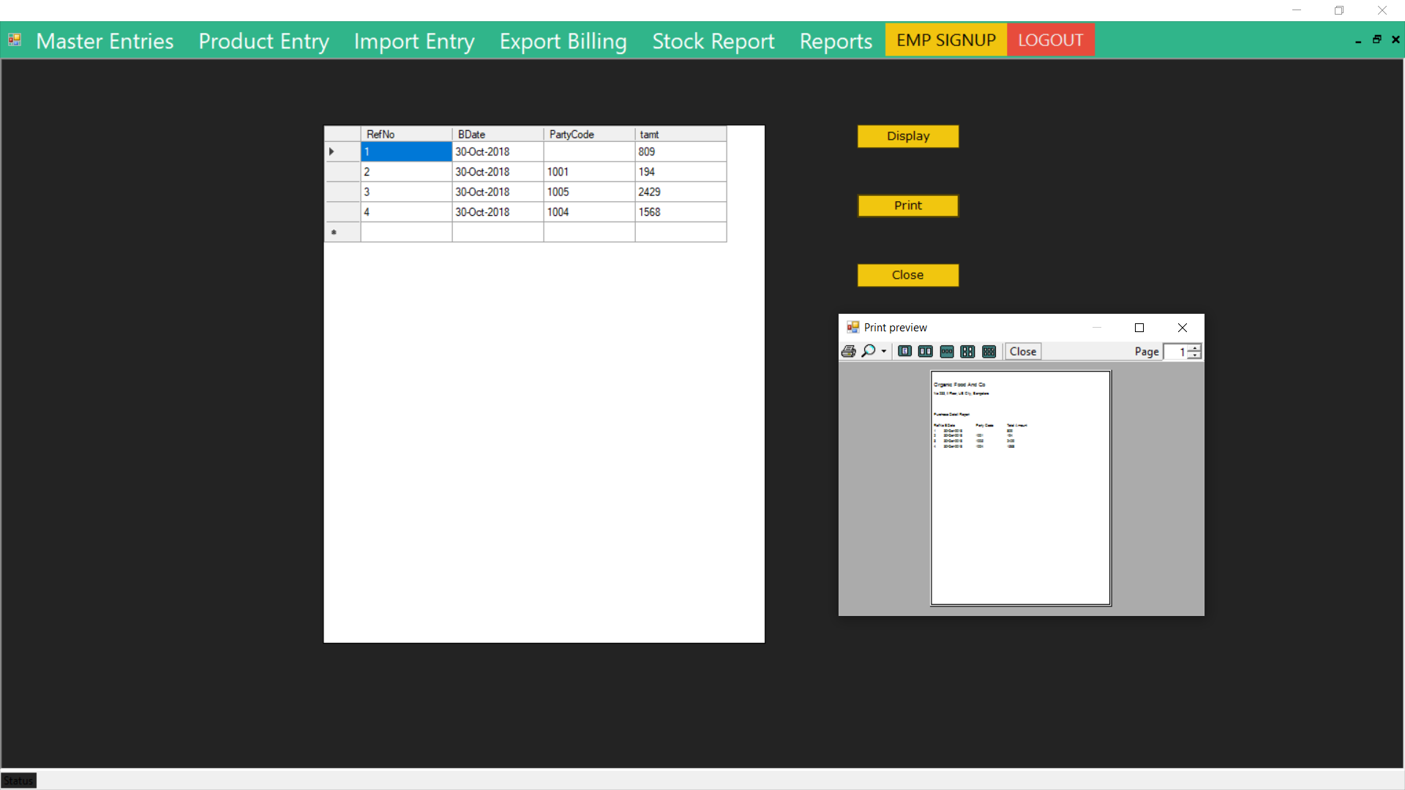

**5th SEM BCA , Seshadripuram Degree College 29**

**Billing System And Shopping Cart**

**6.17 Customer Screen:**

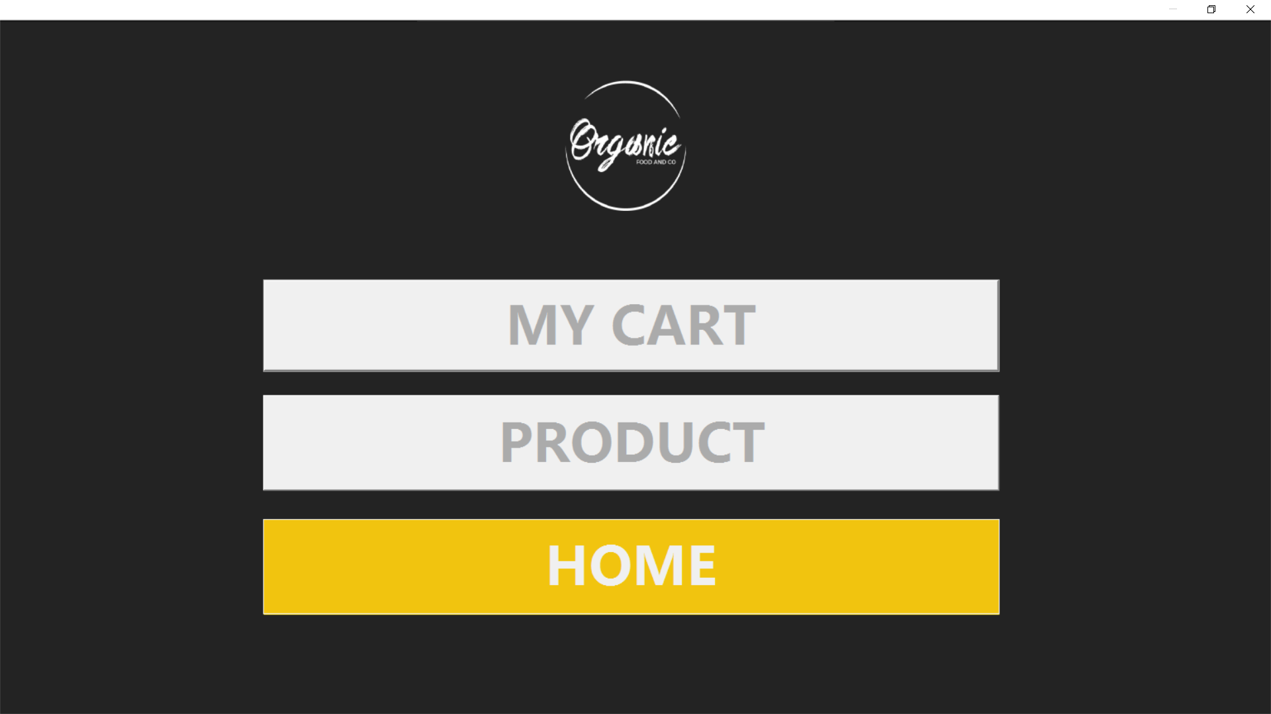

**6.18 About Us Page:**

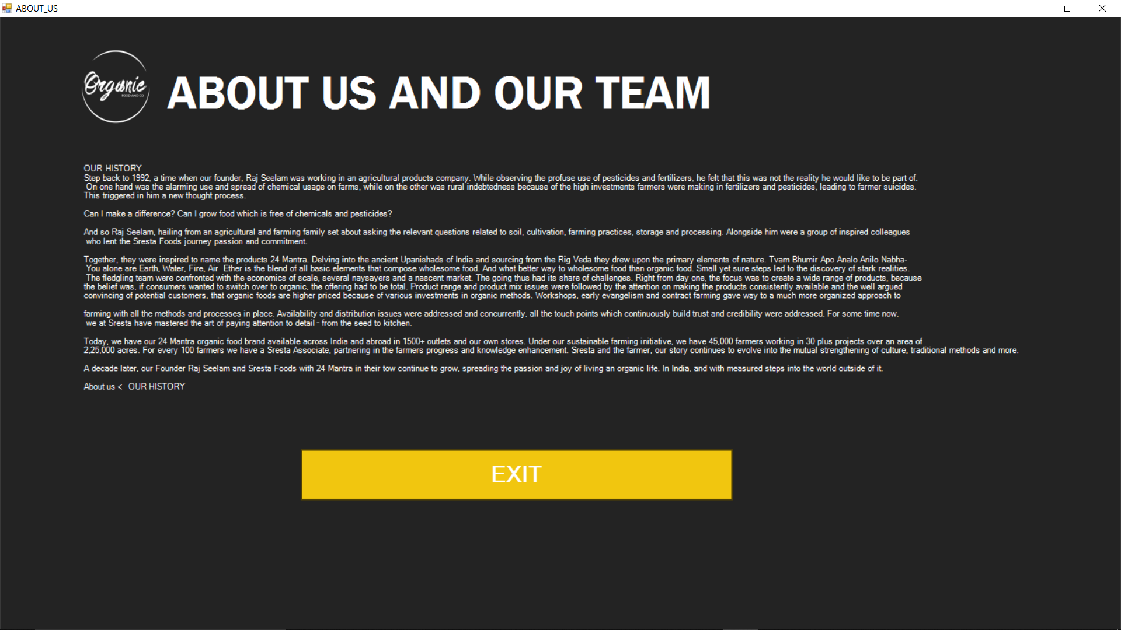

**5th SEM BCA , Seshadripuram Degree College 30**

**Billing System And Shopping Cart**

**6.19 Products Page:**

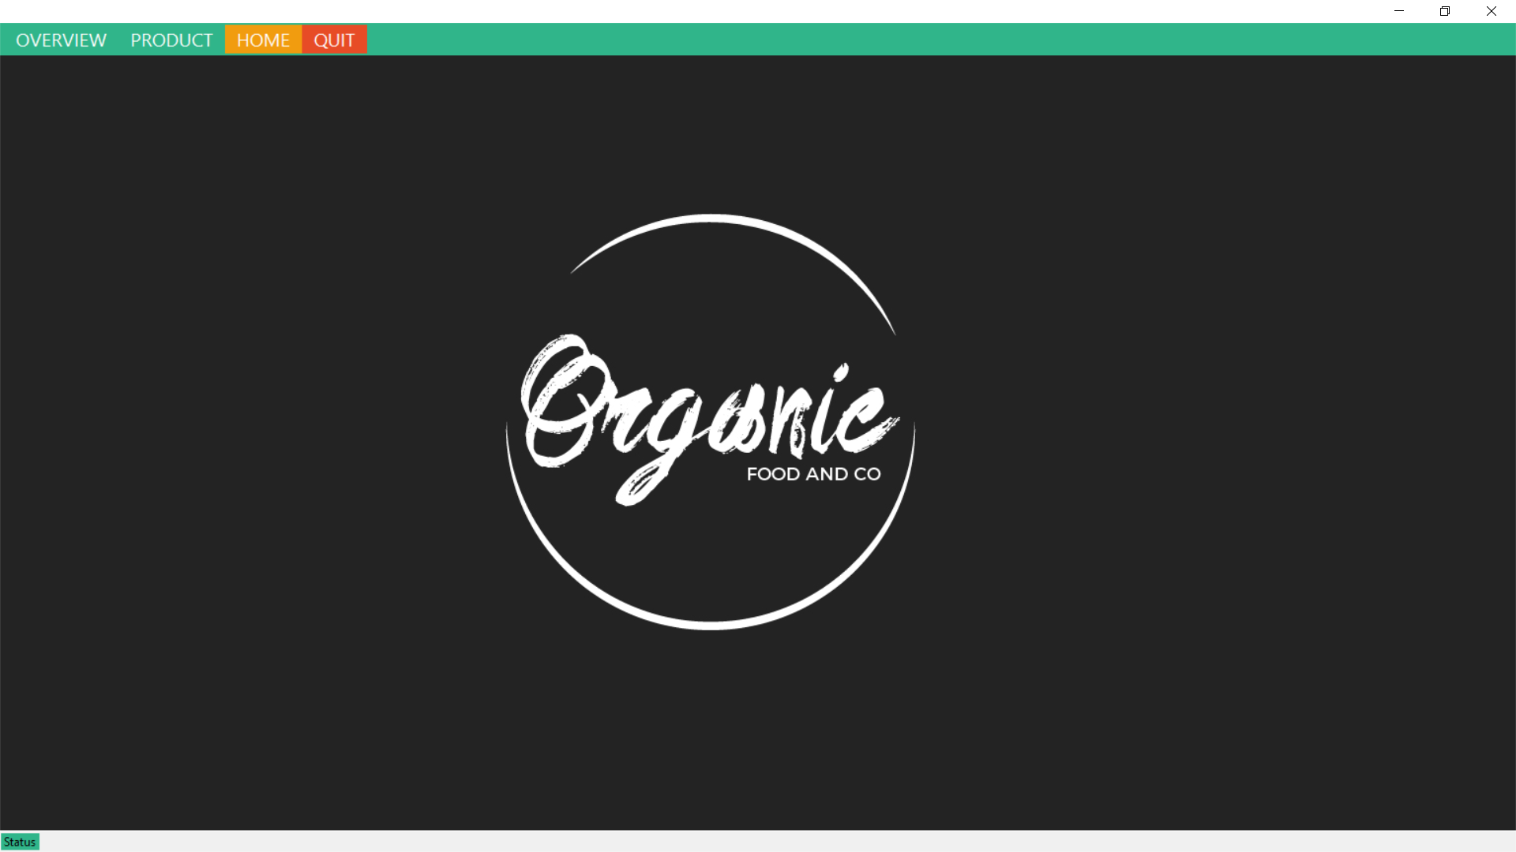

**6.20 Rice Page:**

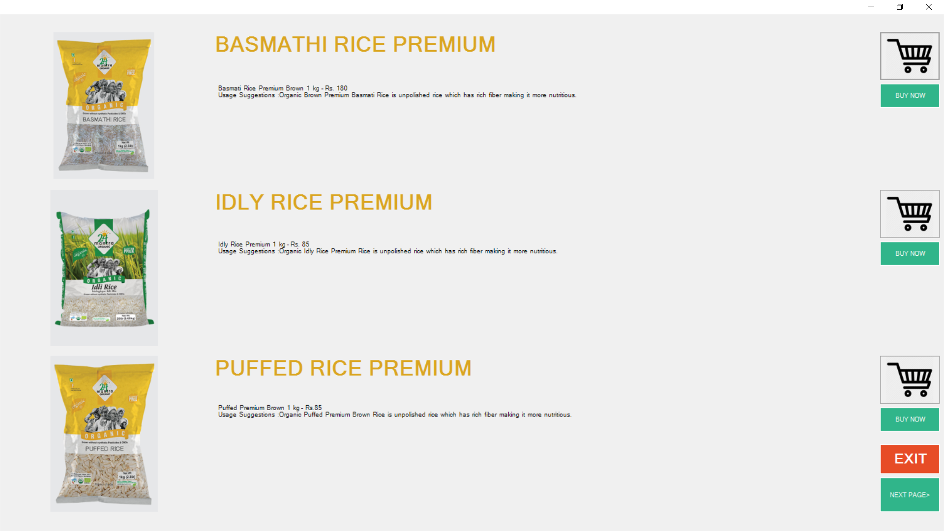

**5th SEM BCA , Seshadripuram Degree College 31**

**Billing System And Shopping Cart**

**6.21 Dals Page:**

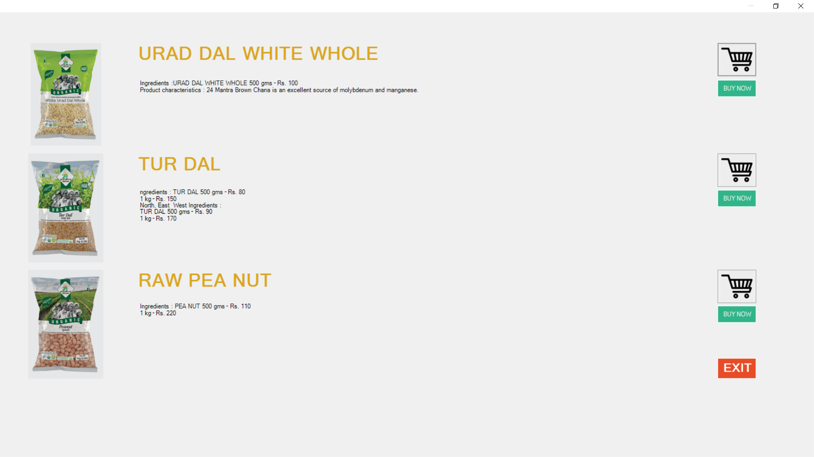

**6.22 Millets Page:**

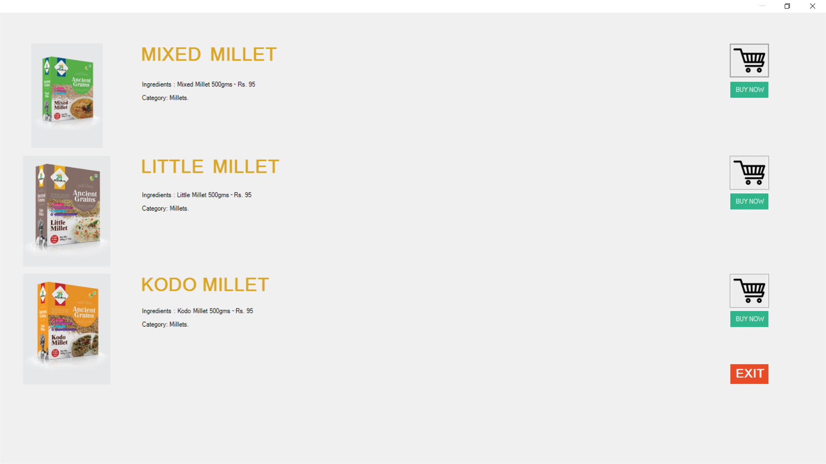

**5th SEM BCA , Seshadripuram Degree College 32**

**Billing System And Shopping Cart**

**6.23 Spices Page:**

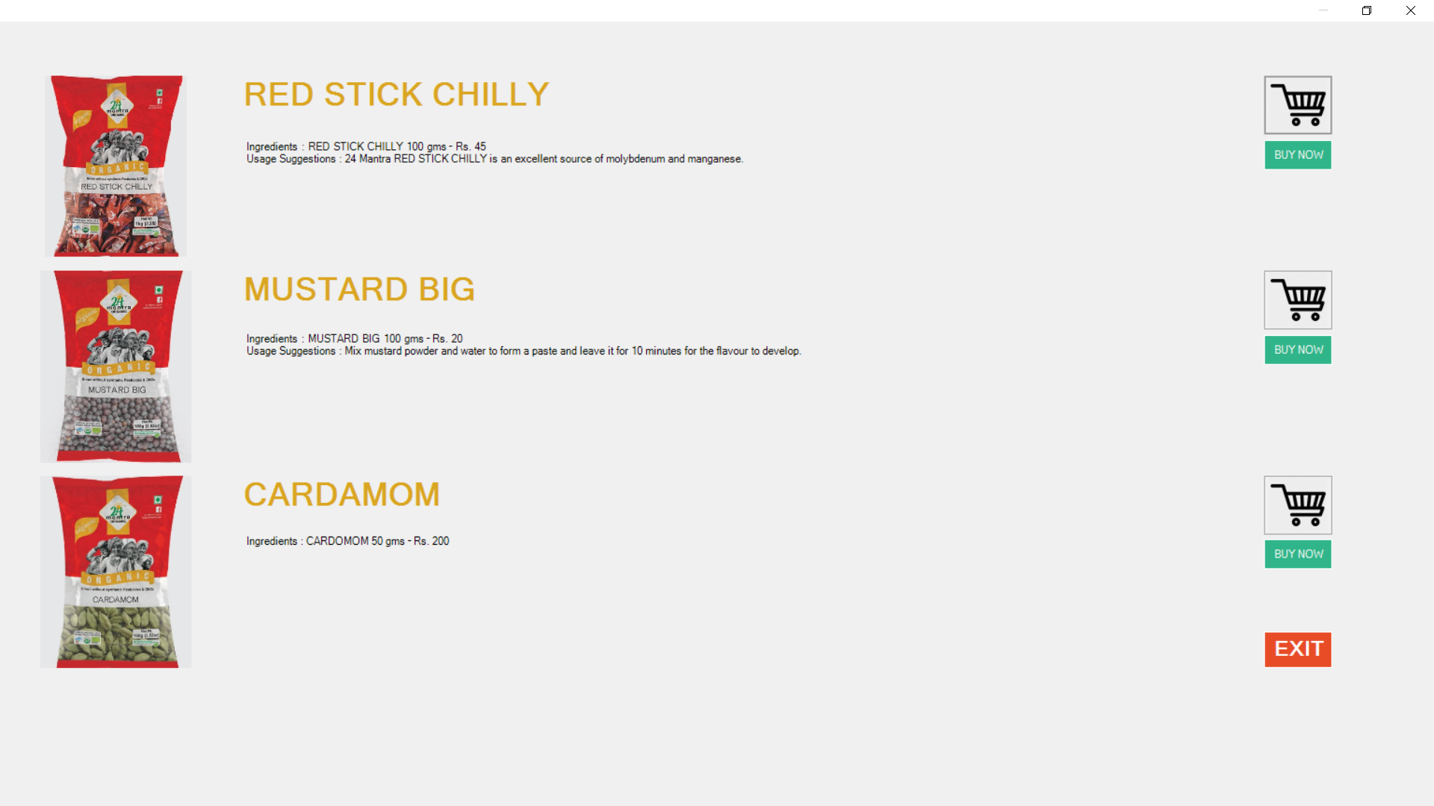

**6.24 Oils Page:**

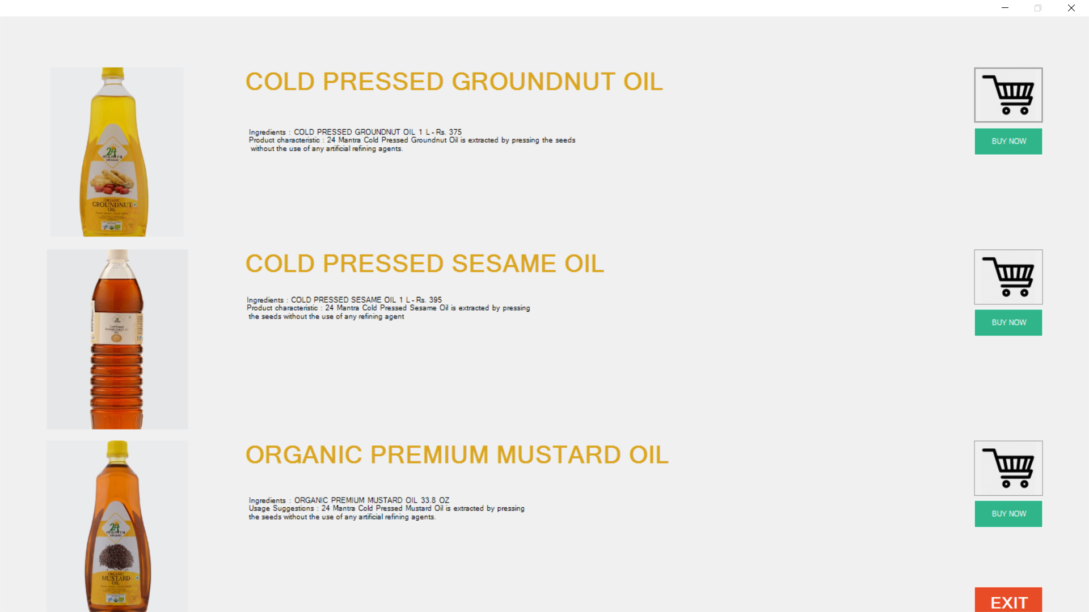

**5th SEM BCA , Seshadripuram Degree College 33**

**Billing System And Shopping Cart**

**6.25 Teas Page:**

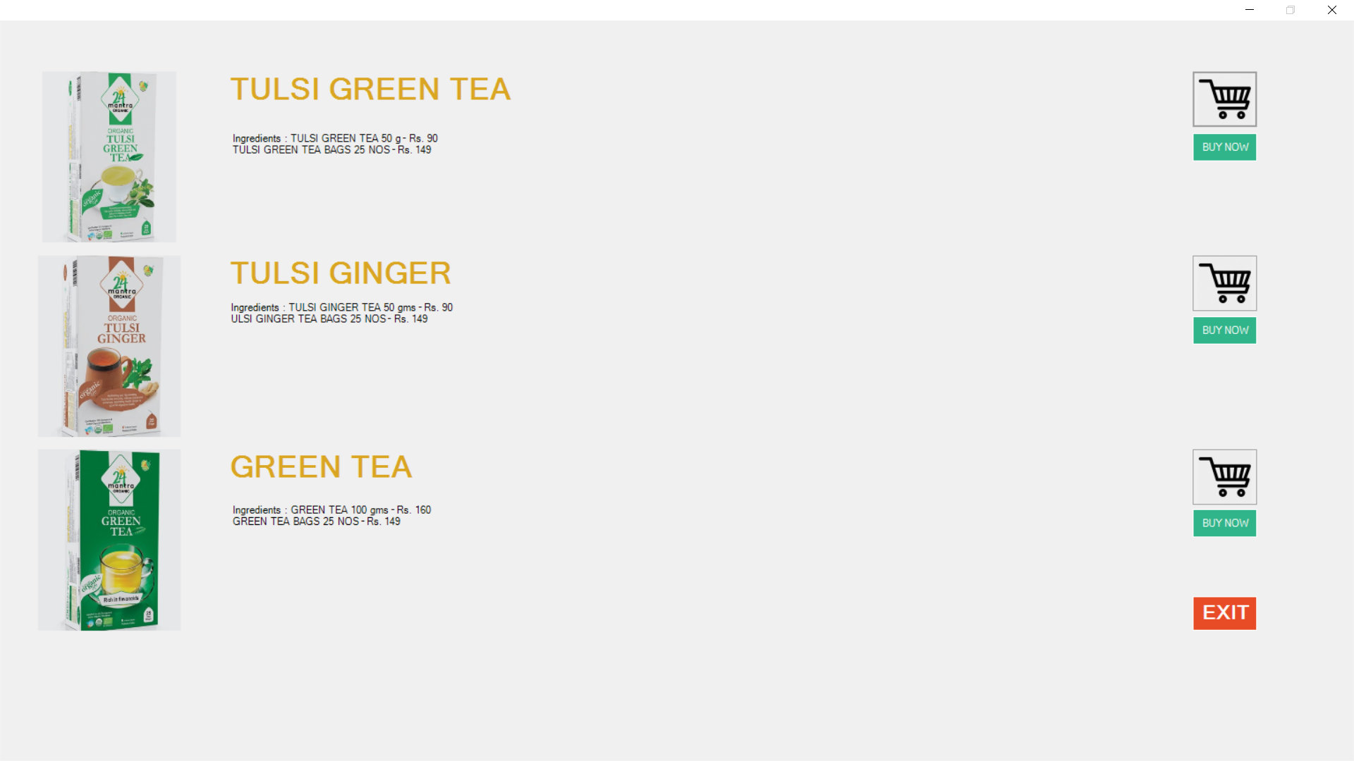

**6.26 Juices Page:**

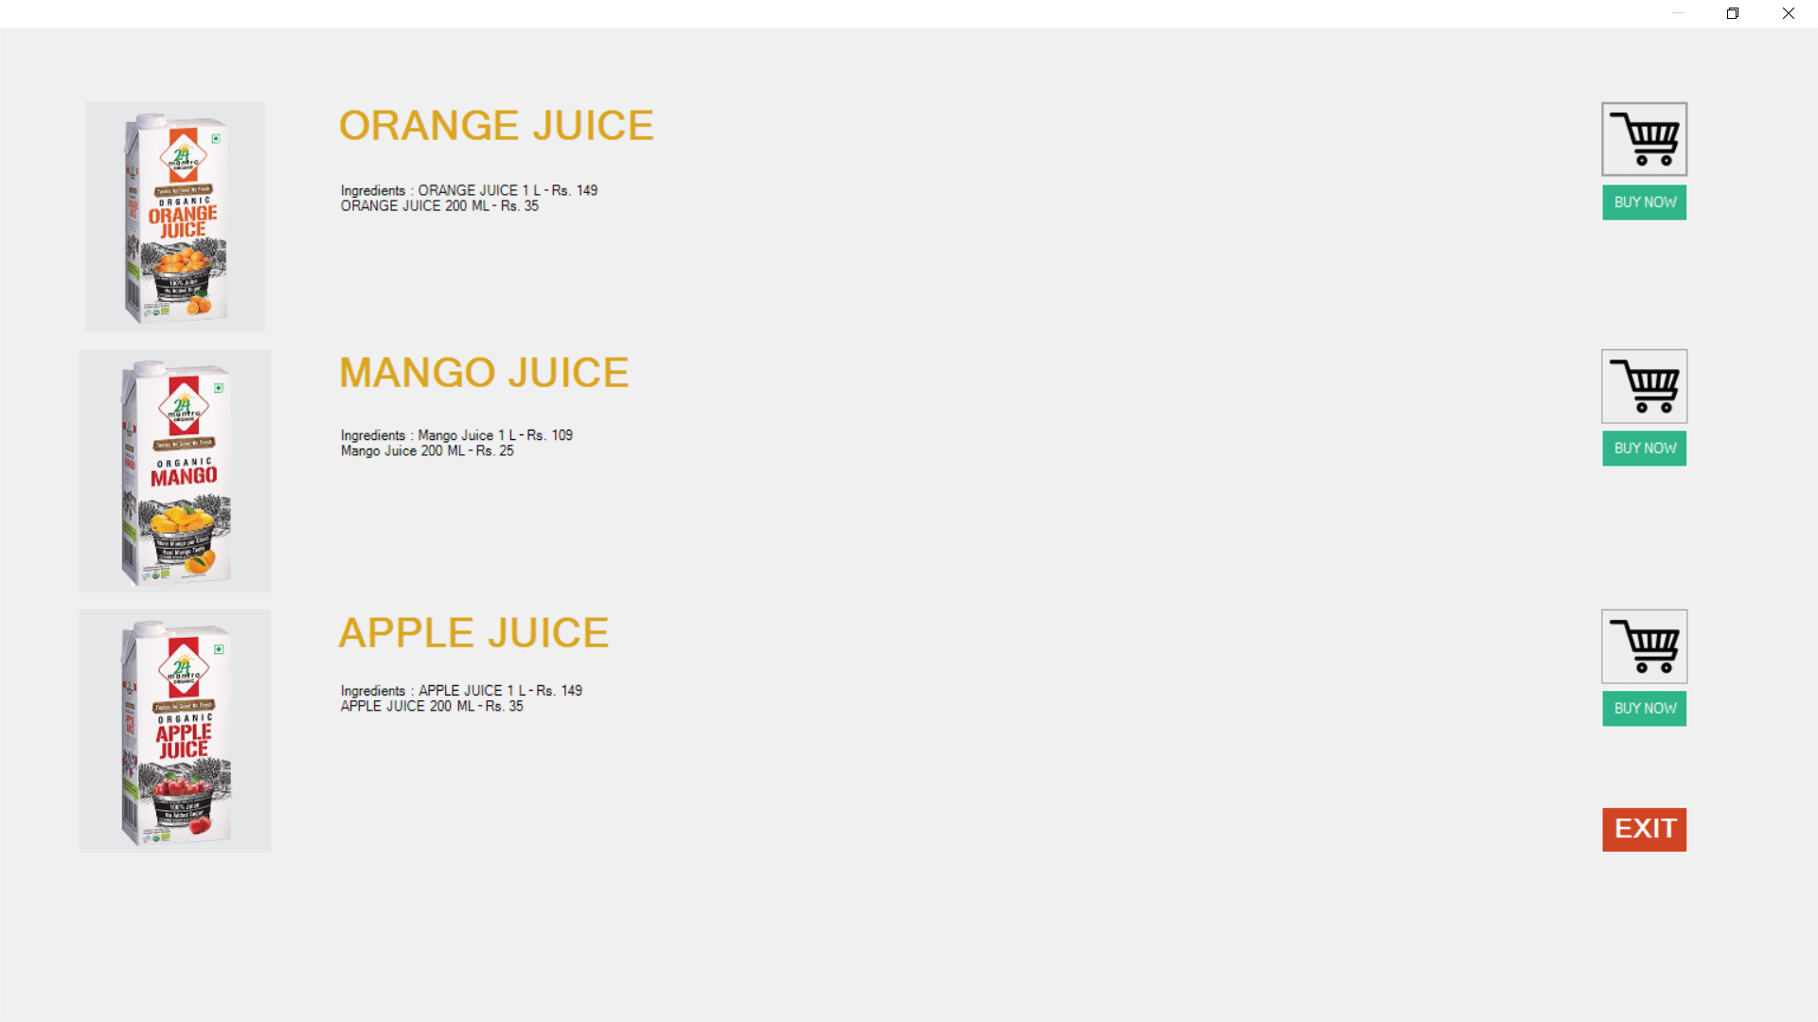

**5th SEM BCA , Seshadripuram Degree College 34**

**Billing System And Shopping Cart**

CODING

**5th SEM BCA , Seshadripuram Degree College 35**

**Billing System And Shopping Cart**

**7.1 Start Page:**

Public Class Form1

Dim i As Integer

Private Sub Timer1_Tick(sender As System.Object, e As System.EventArgs) Handles Timer1.Tick

If (ProgressBar1.Value = ProgressBar1.Maximum) Then

Timer1.Stop()

Me.Hide()

CUSTOMER_AND_USER.Show()

Else

ProgressBar1.PerformStep()

Label1.Text = ProgressBar1.Value & ("%")

End If

End Sub

Private Sub Button1_Click(sender As System.Object, e As System.EventArgs)

Me.Close()

End Sub

Private Sub ProgressBar1_Click(sender As System.Object, e As System.EventArgs) Handles ProgressBar1.Click

End Sub

Private Sub Form1_Load(sender As System.Object, e As System.EventArgs) Handles MyBase.Load

Timer1.Start()

End Sub

End Class

**5th SEM BCA , Seshadripuram Degree College 36**

**Billing System And Shopping Cart**

**7.2 Main Page:**

Imports System.Windows.Forms

Public Class MDIParent1

Private Sub CustomerEntryToolStripMenuItem_Click(sender As System.Object, e As System.EventArgs) Handles CustomerEntryToolStripMenuItem.Click

CustForm.MdiParent = Me

CustForm.Show()

End Sub

Private Sub SupplierEntryToolStripMenuItem_Click(sender As System.Object, e As System.EventArgs) Handles SupplierEntryToolStripMenuItem.Click

SupplierForm.MdiParent = Me

SupplierForm.Show()

End Sub

Private Sub CategoryEntryToolStripMenuItem_Click(sender As System.Object, e As System.EventArgs) Handles CategoryEntryToolStripMenuItem.Click

CategoryForm.MdiParent = Me

CategoryForm.Show()

End Sub

Private Sub GroupEntryToolStripMenuItem_Click(sender As System.Object, e As System.EventArgs) Handles GroupEntryToolStripMenuItem.Click

GroupForm.MdiParent = Me

GroupForm.Show()

End Sub

Private Sub StockReportToolStripMenuItem_Click(sender As System.Object, e As System.EventArgs) Handles StockReportToolStripMenuItem.Click

StockReport.MdiParent = Me

StockReport.Show()

End Sub

Private Sub ImportEntryToolStripMenuItem_Click(sender As System.Object, e As System.EventArgs) Handles ImportEntryToolStripMenuItem.Click

PurchaseImportForm.MdiParent = Me

PurchaseImportForm.Show() **37**

End Sub

Private Sub ProductEntryToolStripMenuItem_Click(sender As System.Object, e As System.EventArgs) Handles ProductEntryToolStripMenuItem.Click

ItemForm.MdiParent = Me

ItemForm.Show()

End Sub

Private Sub ExportBillingToolStripMenuItem_Click(sender As System.Object, e As System.EventArgs) Handles ExportBillingToolStripMenuItem.Click

ExportBillingForm.MdiParent = Me

ExportBillingForm.Show()

End Sub

Private Sub ImportReportsToolStripMenuItem_Click(sender As System.Object, e As System.EventArgs) Handles ImportReportsToolStripMenuItem.Click

PurchaseReport.MdiParent = Me

PurchaseReport.Show()

End Sub

Private Sub ExportReportsToolStripMenuItem_Click(sender As System.Object, e As System.EventArgs) Handles ExportReportsToolStripMenuItem.Click

SalesReport.MdiParent = Me

SalesReport.Show()

End Sub

Private Sub MDIParent1_Load(sender As System.Object, e As System.EventArgs) Handles MyBase.Load

Me.WindowState = FormWindowState.Maximized

End Sub

Private Sub LOGOUTToolStripMenuItem_Click(sender As System.Object, e As System.EventArgs) Handles LOGOUTToolStripMenuItem.Click

If vbNo = MsgBox("Are you sure you want modify this record", MsgBoxStyle.YesNo, "yes,no") Then Exit Sub

Me.Hide()

CUSTOMER_AND_USER.Show()

End Sub

Private Sub SIGNUPToolStripMenuItem_Click(sender As System.Object, e As System.EventArgs) Handles SIGNUPToolStripMenuItem.Click

Me.Hide()

Form2.Show()

End Sub

Private Sub MasterEntriesToolStripMenuItem_Click(sender As System.Object, e As System.EventArgs) Handles MasterEntriesToolStripMenuItem.Click

End Sub

End Class

**38**

**5th SEM BCA , Seshadripuram Degree College**

**Billing System And Shopping Cart**

**7.3 User Login Page:**

Imports System.Data.SqlClient

Public Class LoginForm1

' TODO: Insert code to perform custom authentication using the provided username and password

' (See http://go.microsoft.com/fwlink/?LinkId=35339).

' The custom principal can then be attached to the current thread's principal as follows:

' My.User.CurrentPrincipal = CustomPrincipal

' where CustomPrincipal is the IPrincipal implementation used to perform authentication.

' Subsequently, My.User will return identity information encapsulated in the CustomPrincipal object

' such as the username, display name, etc.

Private Sub Cancel_Click(ByVal sender As System.Object, ByVal e As System.EventArgs)

Me.Hide()

CUSTOMER_AND_USER.Show()

End Sub

Private Sub Button1_Click(sender As System.Object, e As System.EventArgs)

Form2.Show()

End Sub

Private Sub LoginForm1_Load(sender As System.Object, e As System.EventArgs) Handles MyBase.Load

PasswordTextBox.UseSystemPasswordChar = True

End Sub

**39**

Private Sub UsernameLabel_Click(sender As System.Object, e As System.EventArgs)

End Sub

Private Sub UsernameTextBox_TextChanged_1(sender As System.Object, e As System.EventArgs) Handles UsernameTextBox.TextChanged

End Sub

Private Sub CheckBox1_CheckedChanged(sender As System.Object, e As System.EventArgs) Handles CheckBox1.CheckedChanged

If PasswordTextBox.UseSystemPasswordChar = True Then

PasswordTextBox.UseSystemPasswordChar = False

Else

PasswordTextBox.UseSystemPasswordChar = True

End If

End Sub

Private Sub Label1_Click(sender As System.Object, e As System.EventArgs) Handles Label1.Click

Form3.Show()

End Sub

Private Sub OK_Click_1(sender As System.Object, e As System.EventArgs) Handles OK.Click

If UsernameTextBox.Text = My.Settings.username And PasswordTextBox.Text = My.Settings.password Or UsernameTextBox.Text = My.Settings.newpassword And PasswordTextBox.Text = My.Settings.conformpassword Then

MsgBox("welcome user")

MDIParent1.Show()

Else

MsgBox("UserName Or Password Is Incorrect")

MDIParent1.Close()

End If

Me.Close()

End Sub

Private Sub Button1_Click_2(sender As System.Object, e As System.EventArgs) Handles Button1.Click

If vbNo = MsgBox("Are you sure you want modify this record", MsgBoxStyle.YesNo, "yes,no") Then Exit Sub **40**

Me.Hide()

CUSTOMER_AND_USER.Show()

End Sub

Private Sub PictureBox1_Click(sender As System.Object, e As System.EventArgs) Handles PictureBox1.Click

End Sub

End Class

**7.4 Customer And User Page:**

Public Class CUSTOMER_AND_USER

Private Sub PictureBox1_Click(sender As System.Object, e As System.EventArgs)

End Sub

Private Sub Button2_Click(sender As System.Object, e As System.EventArgs) Handles Button2.Click

Me.Hide()

LoginForm1.Show()

End Sub

Private Sub Button1_Click(sender As System.Object, e As System.EventArgs) Handles Button1.Click

Me.Hide()

Customer.Show()

Me.Close()

End Sub

Private Sub PictureBox2_Click(sender As System.Object, e As System.EventArgs) Handles PictureBox2.Click

End Sub

Private Sub CUSTOMER_AND_USER_Load(sender As System.Object, e As System.EventArgs) Handles MyBase.Load

Me.WindowState = FormWindowState.Maximized

End Sub

End Class

**5th SEM BCA , Seshadripuram Degree College 41**

**Billing System And Shopping Cart**

**7.4 Customer And User Page:**

Imports System.Data.SqlClient

Public Class CustForm

Dim pkVar As String

Private Sub custForm_Load(ByVal sender As Object, ByVal e As System.EventArgs) Handles Me.Load

Me.WindowState = FormWindowState.Maximized

disRecords()

End Sub

Private Sub butSave_Click(ByVal sender As System.Object, ByVal e As System.EventArgs) Handles butSave.Click

SaveRecord()

End Sub

Sub SaveRecord()

If TextBox1.Text = "" Then

MsgBox("Please enter the necessary details")

Exit Sub

End If

If Conn.State = ConnectionState.Open Then Conn.Close()

Conn.Open()

Dim Cmd0 As New SqlCommand("select custCode from CustTab where custCode='" & UCase(TextBox1.Text) & "'", Conn)

Dim D1 As SqlDataReader = Cmd0.ExecuteReader()

If D1.HasRows Then

MsgBox("This record is allready present in the database")

If Conn.State = ConnectionState.Open Then Conn.Close()

Exit Sub

End If

If Conn.State = ConnectionState.Open Then Conn.Close()

Conn.Open()

q1Var = "insert into CustTab("

q2Var = " values("

q1Var = q1Var & "custCode" & ","

q2Var = q2Var & "'" & UCase(TextBox1.Text) & "',"

q1Var = q1Var & "custname" & ","

q2Var = q2Var & "'" & TextBox2.Text & "',"

q1Var = q1Var & "Add1" & ","

q2Var = q2Var & "'" & TextBox3.Text & "',"

q1Var = q1Var & "Add2" & ","

q2Var = q2Var & "'" & TextBox4.Text & "',"

q1Var = q1Var & "Add3" & ","

q2Var = q2Var & "'" & TextBox5.Text & "',"

q1Var = q1Var & "PinCode" & ","

q2Var = q2Var & "'" & TextBox6.Text & "'," **42**

q1Var = q1Var & "PhoneNo" & ","

q2Var = q2Var & "'" & TextBox7.Text & "',"

q1Var = q1Var & "eMail" & ")"

q2Var = q2Var & "'" & TextBox8.Text & "')"

MsgBox(q1Var & q2Var)

Dim cmd1 As New SqlCommand(q1Var & q2Var, Conn)

cmd1.ExecuteNonQuery()

If Conn.State = ConnectionState.Open Then Conn.Close()

disRecords()

End Sub

Sub disRecords()

If Conn.State = ConnectionState.Open Then Conn.Close()

Conn.Open()

Dim DS1 As New DataSet

Dim adp As New SqlDataAdapter("Select custCode,CustName From CustTab order by custCode", Conn)

adp.Fill(DS1)

DG1.DataSource = DS1.Tables(0)

If Conn.State = ConnectionState.Open Then Conn.Close()

End Sub

Private Sub DG1_CellContentClick(sender As System.Object, e As System.Windows.Forms.DataGridViewCellEventArgs) Handles DG1.CellContentClick

pkVar = DG1.CurrentRow.Cells(0).Value

If Conn.State = ConnectionState.Open Then Conn.Close()

Conn.Open()

Dim Cmd0 As New SqlCommand("select * from CustTab where custCode='" & pkVar & "'", Conn)

Dim D1 As SqlDataReader = Cmd0.ExecuteReader()

If D1.HasRows Then

D1.Read()

TextBox1.Text = D1(0).ToString

TextBox2.Text = D1(1).ToString

TextBox3.Text = D1(2).ToString

TextBox4.Text = D1(3).ToString

TextBox5.Text = D1(4).ToString

TextBox6.Text = D1(5).ToString

TextBox7.Text = D1(6).ToString

TextBox8.Text = D1(7).ToString

Else

TextBox1.Text = ""

TextBox2.Text = ""

End If

If Conn.State = ConnectionState.Open Then Conn.Close()

End Sub

Private Sub butClose_Click(sender As System.Object, e As System.EventArgs) Handles butClose.Click

Me.Close()

End Sub **43**

Private Sub butModify_Click(ByVal sender As Object, ByVal e As System.EventArgs) Handles butModify.Click

If vbNo = MsgBox("Are you sure you want modify this record", MsgBoxStyle.YesNo, "Delete") Then Exit Sub

If Conn.State = ConnectionState.Open Then Conn.Close()

Conn.Open()

Dim cmd1 As New SqlCommand("Delete from CustTab where custCode='" & pkVar & "'", Conn)

cmd1.ExecuteNonQuery()

If Conn.State = ConnectionState.Open Then Conn.Close()

SaveRecord()

End Sub

Private Sub ButDelete_Click(ByVal sender As Object, ByVal e As System.EventArgs) Handles butDelete.Click

If vbNo = MsgBox("Are you sure you want delete this record", MsgBoxStyle.YesNo, "Delete") Then Exit Sub

If Conn.State = ConnectionState.Open Then Conn.Close()

Conn.Open()

Dim cmd1 As New SqlCommand("Delete from CustTab where custCode='" & pkVar & "'", Conn)

cmd1.ExecuteNonQuery()

If Conn.State = ConnectionState.Open Then Conn.Close()

disRecords()

End Sub

Private Sub butList_Click(ByVal sender As System.Object, ByVal e As System.EventArgs) Handles butList.Click

disRecords()

End Sub

Private Sub TextBox1_LostFocus(ByVal sender As Object, ByVal e As System.EventArgs) Handles TextBox1.LostFocus

TextBox1.Text = UCase(TextBox1.Text)

End Sub

Private Sub TextBox7_TextChanged(sender As System.Object, e As System.EventArgs) Handles TextBox7.TextChanged

End Sub

Private Sub TextBox7_KeyPress(sender As Object, e As System.Windows.Forms.KeyPressEventArgs) Handles TextBox7.KeyPress

e.KeyChar = CheckNum(e.KeyChar)

End Sub

Private Sub Label4_Click(sender As System.Object, e As System.EventArgs) Handles Label4.Click

End Sub

Private Sub TextBox6_KeyPress(sender As Object, e As System.Windows.Forms.KeyPressEventArgs) Handles TextBox6.KeyPress **44**

e.KeyChar = CheckNum(e.KeyChar)

End Sub

Private Sub TextBox6_TextChanged(sender As System.Object, e As System.EventArgs) Handles TextBox6.TextChanged

End Sub

End Class

Imports System.Data.SqlClient

Public Class CategoryForm

Dim pkVar As String

Private Sub CategoryForm_Load(ByVal sender As Object, ByVal e As System.EventArgs)

Me.WindowState = FormWindowState.Maximized

disRecords()

End Sub

Private Sub butClose_Click(ByVal sender As System.Object, ByVal e As System.EventArgs)

Me.Close()

End Sub

Private Sub butNew_Click1(ByVal sender As Object, ByVal e As System.EventArgs) Handles butNew.Click

End Sub

Private Sub butList_Click(ByVal sender As System.Object, ByVal e As System.EventArgs) Handles butList.Click

disRecords()

End Sub

Private Sub butSave_Click_1(sender As System.Object, e As System.EventArgs) Handles butSave.Click

SaveRecord()

End Sub

Sub SaveRecord()

If TextBox1.Text = "" Then

MsgBox("Please enter the necessary details")

Exit Sub

End If

If Conn.State = ConnectionState.Open Then Conn.Close()

Conn.Open() **45**

Dim Cmd0 As New SqlCommand("select CatName from CatTab where CatName='" & UCase(TextBox1.Text) & "'", Conn)

Dim D1 As SqlDataReader = Cmd0.ExecuteReader()

If D1.HasRows Then

MsgBox("This record is allready present in the database")

If Conn.State = ConnectionState.Open Then Conn.Close()

Exit Sub

End If

If Conn.State = ConnectionState.Open Then Conn.Close()

Conn.Open()

q1var = "insert into CatTab("

q2var = " values("

q1var = q1var & "CatName" & ","

q2var = q2var & "'" & UCase(TextBox1.Text) & "',"

q1var = q1var & "Details" & ")"

q2var = q2var & "'" & TextBox2.Text & "')"

MsgBox(q1var & q2var)

Dim cmd1 As New SqlCommand(q1var & q2var, Conn)

cmd1.ExecuteNonQuery()

If Conn.State = ConnectionState.Open Then Conn.Close()

disRecords()

End Sub

Sub disRecords()

If Conn.State = ConnectionState.Open Then Conn.Close()

Conn.Open()

Dim DS1 As New DataSet

Dim adp As New SqlDataAdapter("Select CatName,Details From CatTab order by CatName", Conn)

adp.Fill(DS1)

DG1.DataSource = DS1.Tables(0)

If Conn.State = ConnectionState.Open Then Conn.Close()

End Sub

Private Sub butClose_Click_1(sender As System.Object, e As System.EventArgs) Handles butClose.Click

Me.Close()

End Sub

Private Sub CategoryForm_Load_1(sender As System.Object, e As System.EventArgs) Handles MyBase.Load

End Sub

Private Sub butDelete_Click_1(sender As System.Object, e As System.EventArgs) Handles butDelete.Click

If vbNo = MsgBox("Are you sure you want delete this record", MsgBoxStyle.YesNo, "Delete") Then Exit Sub

If Conn.State = ConnectionState.Open Then Conn.Close()

Conn.Open()

Dim cmd1 As New SqlCommand("Delete from CatTab where CatName='" & pkVar & "'", Conn)

cmd1.ExecuteNonQuery() **46**

If Conn.State = ConnectionState.Open Then Conn.Close()

disRecords()

End Sub

Private Sub butModify_Click_1(sender As System.Object, e As System.EventArgs) Handles butModify.Click

If vbNo = MsgBox("Are you sure you want modify this record", MsgBoxStyle.YesNo, "Delete") Then Exit Sub

If Conn.State = ConnectionState.Open Then Conn.Close()

Conn.Open()

Dim cmd1 As New SqlCommand("Delete from CatTab where CatName='" & pkVar & "'", Conn)

cmd1.ExecuteNonQuery()

If Conn.State = ConnectionState.Open Then Conn.Close()

SaveRecord()

End Sub

Private Sub DG1_CellContentClick_1(sender As System.Object, e As System.Windows.Forms.DataGridViewCellEventArgs) Handles DG1.CellContentClick

pkVar = DG1.CurrentRow.Cells(0).Value

If Conn.State = ConnectionState.Open Then Conn.Close()

Conn.Open()

Dim Cmd0 As New SqlCommand("select * from CatTab where CatName='" & pkVar & "'", Conn)

Dim D1 As SqlDataReader = Cmd0.ExecuteReader()

If D1.HasRows Then

D1.Read()

TextBox1.Text = D1(0).ToString

TextBox2.Text = D1(1).ToString

Else

TextBox1.Text = ""

TextBox2.Text = ""

End If

If Conn.State = ConnectionState.Open Then Conn.Close()

End Sub

End Class

Imports System.Data.SqlClient

Public Class SupplierForm

Dim pkVar As String

Private Sub suppForm_Load(ByVal sender As Object, ByVal e As System.EventArgs) Handles Me.Load

Me.WindowState = FormWindowState.Maximized

disRecords()

End Sub

**47**

Private Sub butSave_Click(ByVal sender As System.Object, ByVal e As System.EventArgs) Handles butSave.Click

SaveRecord()

End Sub

Sub SaveRecord()

If TextBox1.Text = "" Then

MsgBox("Please enter the necessary details")

Exit Sub

End If

If Conn.State = ConnectionState.Open Then Conn.Close()

Conn.Open()

Dim Cmd0 As New SqlCommand("select suppcode from supptab where suppcode='" & UCase(TextBox1.Text) & "'", Conn)

Dim D1 As SqlDataReader = Cmd0.ExecuteReader()

If D1.HasRows Then

MsgBox("This record is allready present in the database")

If Conn.State = ConnectionState.Open Then Conn.Close()

Exit Sub

End If

If Conn.State = ConnectionState.Open Then Conn.Close()

Conn.Open()

q1var = "insert into supptab("

q2var = " values("

q1var = q1var & "suppcode" & ","

q2var = q2var & "'" & UCase(TextBox1.Text) & "',"

q1var = q1var & "suppname" & ","

q2var = q2var & "'" & TextBox2.Text & "',"

q1var = q1var & "Add1" & ","

q2var = q2var & "'" & TextBox3.Text & "',"

q1var = q1var & "Add2" & ","

q2var = q2var & "'" & TextBox4.Text & "',"

q1var = q1var & "Add3" & ","

q2var = q2var & "'" & TextBox5.Text & "',"

q1var = q1var & "PinCode" & ","

q2var = q2var & "'" & TextBox6.Text & "',"

q1var = q1var & "PhoneNo" & ","

q2var = q2var & "'" & TextBox7.Text & "',"

q1var = q1var & "eMail" & ")"

q2var = q2var & "'" & TextBox8.Text & "')"

MsgBox(q1var & q2var)

Dim cmd1 As New SqlCommand(q1var & q2var, Conn)

cmd1.ExecuteNonQuery()

If Conn.State = ConnectionState.Open Then Conn.Close()

disRecords()

End Sub

Sub disRecords()

If Conn.State = ConnectionState.Open Then Conn.Close()

Conn.Open()

Dim DS1 As New DataSet

Dim adp As New SqlDataAdapter("Select suppcode,suppname From supptab order by suppcode", Conn)

adp.Fill(DS1) **48**

DG1.DataSource = DS1.Tables(0)

If Conn.State = ConnectionState.Open Then Conn.Close()

End Sub

Private Sub DG1_CellContentClick(sender As System.Object, e As System.Windows.Forms.DataGridViewCellEventArgs) Handles DG1.CellContentClick

pkVar = DG1.CurrentRow.Cells(0).Value

If Conn.State = ConnectionState.Open Then Conn.Close()

Conn.Open()

Dim Cmd0 As New SqlCommand("select * from supptab where suppcode='" & pkVar & "'", Conn)

Dim D1 As SqlDataReader = Cmd0.ExecuteReader()

If D1.HasRows Then

D1.Read()

TextBox1.Text = D1(0).ToString

TextBox2.Text = D1(1).ToString

TextBox3.Text = D1(2).ToString

TextBox4.Text = D1(3).ToString

TextBox5.Text = D1(4).ToString

TextBox6.Text = D1(5).ToString

TextBox7.Text = D1(6).ToString

TextBox8.Text = D1(7).ToString

Else

TextBox1.Text = ""

TextBox2.Text = ""

End If

If Conn.State = ConnectionState.Open Then Conn.Close()

End Sub

Private Sub butClose_Click(sender As System.Object, e As System.EventArgs) Handles butClose.Click

Me.Close()

End Sub

Private Sub butModify_Click(ByVal sender As Object, ByVal e As System.EventArgs) Handles butModify.Click

If vbNo = MsgBox("Are you sure you want modify this record", MsgBoxStyle.YesNo, "Delete") Then Exit Sub

If Conn.State = ConnectionState.Open Then Conn.Close()

Conn.Open()

Dim cmd1 As New SqlCommand("Delete from supptab where suppcode='" & pkVar & "'", Conn)

cmd1.ExecuteNonQuery()

If Conn.State = ConnectionState.Open Then Conn.Close()

SaveRecord()

End Sub

Private Sub ButDelete_Click(ByVal sender As Object, ByVal e As System.EventArgs) Handles butDelete.Click

If vbNo = MsgBox("Are you sure you want delete this record", MsgBoxStyle.YesNo, "Delete") Then Exit Sub **49**

If Conn.State = ConnectionState.Open Then Conn.Close()

Conn.Open()

Dim cmd1 As New SqlCommand("Delete from supptab where suppcode='" & pkVar & "'", Conn)

cmd1.ExecuteNonQuery()

If Conn.State = ConnectionState.Open Then Conn.Close()

disRecords()

End Sub

Private Sub butList_Click(ByVal sender As System.Object, ByVal e As System.EventArgs) Handles butList.Click

disRecords()

End Sub

Private Sub TextBox1_LostFocus(ByVal sender As Object, ByVal e As System.EventArgs) Handles TextBox1.LostFocus

TextBox1.Text = UCase(TextBox1.Text)

End Sub

Private Sub TextBox7_KeyPress(sender As Object, e As System.Windows.Forms.KeyPressEventArgs) Handles TextBox7.KeyPress

e.KeyChar = CheckNum(e.KeyChar)

End Sub

Private Sub TextBox7_TextChanged(sender As System.Object, e As System.EventArgs) Handles TextBox7.TextChanged

End Sub

Private Sub TextBox6_KeyPress(sender As Object, e As System.Windows.Forms.KeyPressEventArgs) Handles TextBox6.KeyPress

e.KeyChar = CheckNum(e.KeyChar)

End Sub

Private Sub TextBox6_TextChanged(sender As System.Object, e As System.EventArgs) Handles TextBox6.TextChanged

End Sub

End Class

**5th SEM BCA , Seshadripuram Degree College 50**

**Billing System And Shopping Cart**

**CHAPTER-8 CONCLUSION**

The project is developed best on the windows application, the capable of registeringemployees and enabling the customers to loo for their desired product and buy them. Inorder to achieve this some objectives were defined. It is with great experience that I presentthis final review of the system is successfully been developed using a number of tools earlierdiscussed Computer and software li e My SQL. Meanwhile, the careful application of thesetools and have led to development of a system that meets the defined objectives.

**CHAPTER-9 BIBILOGRAPHY**

The References used during the course

The following material was used as the references during the course of the project.

**Text Books**

• Complete Reference VB.Net

• Programming Microsoft VB.NET

•MSQl Reference VB.NET

**www.google.co.in**

**5th SEM BCA , Seshadripuram Degree College 51**